Share your feedback on the draft Governance Rules
Complete our survey by 11.59pm 1 October 2026 to tell us whether or not you support our proposed changes, and why. You can also suggest other ideas to improve our Governance Rules.

Return your completed survey by email to engagement@frankston.vic.gov.au, or in person to a Frankston Library, Customer Service or Community Centre.

Which proposed changes are you sharing feedback on?
Please select which categories of the proposed changes you would like to comment on. You can choose as many as you like.

- Which categories of the proposed changes would you like to comment on? ^{Required}
Select all that apply

Proposed changes to public question time
Proposed changes to public submissions
Proposed changes to notices of motion
Proposed alternate motion rules
Proposed councillor apologies and leave of absence rules
Proposed changes to petition rules
Other proposed changes to Council meeting rules
Other (please specify)

Proposed changes to public question time

- Do you support Council's proposed changes to Public Question Time?
Please respond to as many of the proposed changes as you like. If you do not support a change, please explain why in the next question so that we can make changes where possible.
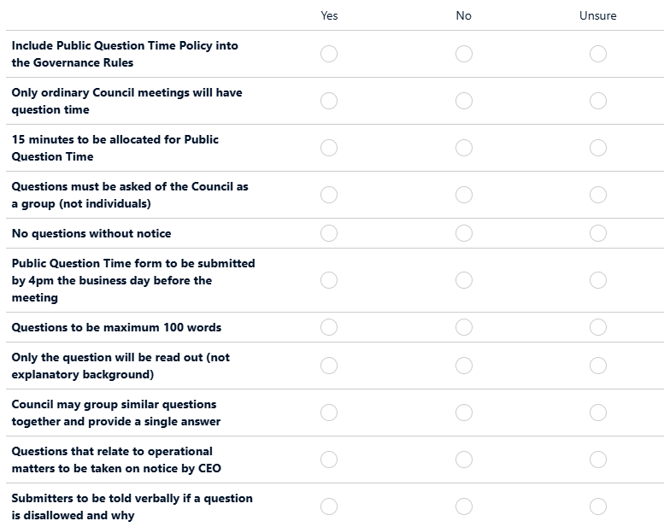
- Please share your reasons
Explaining why you do not support a change will help us improve our proposal and help Council make a decision on whether to proceed.
- What else would improve Public Question Time?
This question is optional. Your ideas will be considered for inclusion in the Governance Rules before they are presented to Council for adoption.

Proposed changes to public submissions

- Do you support Council's proposed changes to Public Submissions?
Please respond to as many of the proposed changes as you like. If you do not support a change, please explain why in the next question so that we can make changes where possible.
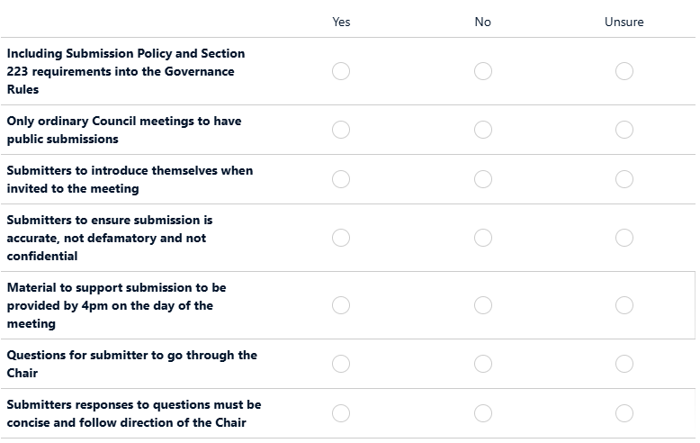
- Please share your reasons
Explaining why you do not support a change will help us improve our proposal and help Council make a decision on whether to proceed.
- What else would improve Public Submissions?
This question is optional. Your ideas will be considered for inclusion in the Governance Rules before they are presented to Council for adoption.

Proposed changes to notices of motion

- Do you support Council's proposed changes to Notices of Motion?
Please respond to as many of the proposed changes as you like. If you do not support a change, please explain why in the next question so that we can make changes where possible.
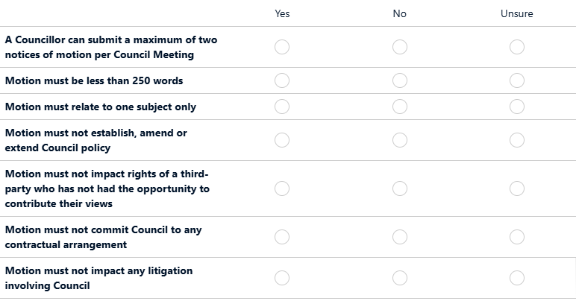
- Please share your reasons
Explaining why you do not support a change will help us improve our proposal and help Council make a decision on whether to proceed.
- What else would improve Notices of Motion?
This question is optional. Your ideas will be considered for inclusion in the Governance Rules before they are presented to Council for adoption.

Proposed alternate motion rules

- Do you support Council's proposed alternate motion rules?
Please respond to as many of the proposed provisions as you like. If you do not support a change, please explain why in the next question so that we can make changes where possible.
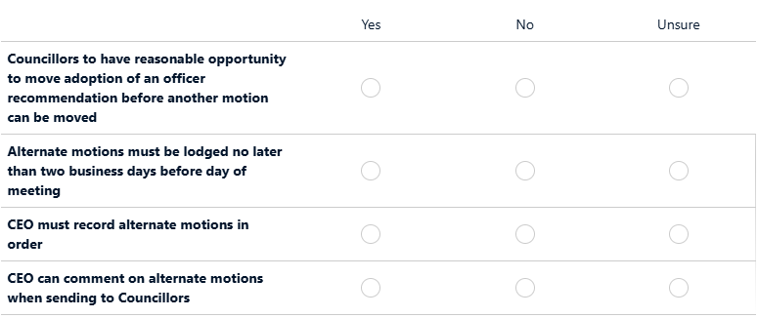
- Please share your reasons
Explaining why you do not support a change will help us improve our proposal and help Council make a decision on whether to proceed.
- What else would improve Alternate Motions?
This question is optional. Your ideas will be considered for inclusion in the Governance Rules before they are presented to Council for adoption.

Proposed councillor apologies and leave of absence rules

- Do you support Council's proposed apologies and leave of absence rules?
Please respond to as many of the proposed provisions as you like. If you do not support a change, please explain why in the next question so that we can make changes where possible.
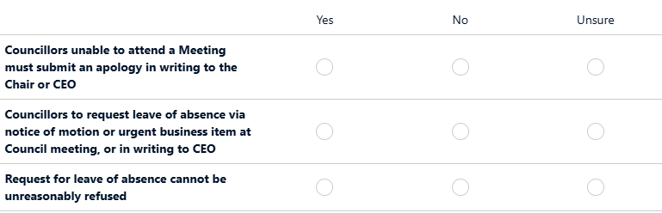
- Please share your reasons
Explaining why you do not support a change will help us improve our proposal and help Council make a decision on whether to proceed.
- What else would improve Councillor Apologies and Leave of Absence rules?
This question is optional. Your ideas will be considered for inclusion in the Governance Rules before they are presented to Council for adoption.

Proposed changes to petition rules

- Do you support Council's proposed changes to petition rules?
Please respond to as many of the proposed provisions as you like. If you do not support a change, please explain why in the next question so that we can make changes where possible.
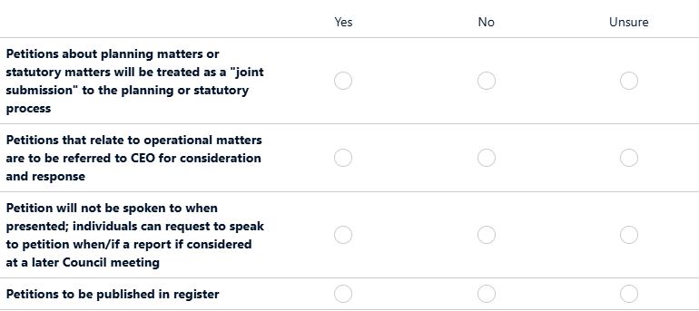
- Please share your reasons
Explaining why you do not support a change will help us improve our proposal and help Council make a decision on whether to proceed.
- What else would improve petitions?
This question is optional. Your ideas will be considered for inclusion in the Governance Rules before they are presented to Council for adoption.

Other proposed changes to Council meeting rules

- Do you support Council's other proposed changes to Council meeting rules?
Please respond to as many of the proposed provisions as you like. If you do not support a change, please explain why in the next question so that we can make changes where possible.
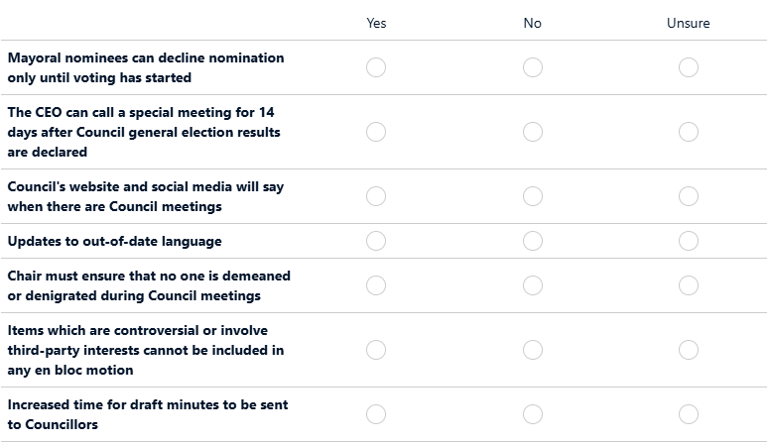
- Please share your reasons
Explaining why you do not support a change will help us improve our proposal and help Council make a decision on whether to proceed.
- What else would improve Council meetings? What rules would encourage you to participate in a Council meeting?
This question is optional. Your ideas will be considered for inclusion in the Governance Rules before they are presented to Council for adoption.

- Do you have any other feedback or ideas for our draft Governance Rules?
This question is optional.

A bit about you

The following questions help us understand who is interested in or impacted by this project. You can select 'prefer not to say'.
- What is your experience with Council meetings? ^{Required}
Select all that apply
I have watched a council meeting online
I have attended a council meeting in person
I have submitted a question to a council meeting
I have spoken at a council meeting
I have participated as a Councillor or council officer
No experience with council meetings
Prefer not to answer
Other (please specify)

- Where do you live? ^{Required}
Select one answer only

Carrum Downs
Frankston
Frankston North
Frankston South
Langwarrin
Langwarrin South
Sandhurst
Seaford
Skye
City of Kingston
City of Greater Dandenong
City of Casey
Mornington Peninsula Shire
Somewhere else
Prefer not to answer
- What best describes your gender? ^{Required}
Select one answer only
Woman or female
Man or male
Non-binary or gender diverse
Prefer not to answer
- Which of the following do you identify with? ^{Required}
Select all that apply
Aboriginal and/or Torres Strait Islander
Part of the LGBTIQA+ community
Speak a language other than English
Person with a disability or long-term health condition
None of these
Prefer not to answer
- What is your age? ^{Required}
Select one answer only
0 – 4 years
5 – 11 years
12 – 17 years
18 – 24 years
25 – 34 years
35 – 49 years
50 – 59 years
60 – 69 years
70 – 84 years
85 years and over
Prefer not to answer
- Would you like to be heard in support of your written submission at a Council Meeting?
Select one answer only
No
Yes, I would like to speak at a Council Meeting
- First Name ^{Required}
- Last Name ^{Required}
- Email address ^{Required}
- Phone number ^{Required}
- Select this box if you have read and understood our privacy statement (below) ^{Required}
Yes

Privacy Statement:
Frankston City Council is committed to protecting your privacy. We welcome anonymous responses to this survey. Any information you provide, including if you choose to provide personal details to register to speak at a Council meeting, will be used for the purpose of informing the revised Governance Rules.
Public reports of the engagement project will include aggregate responses and not identify individuals. Your personal information will only be used and disclosed as authorised by law.
For further information about how Council handles personal information, or to request access to your personal information, see frankston.vic.gov.au or contact Council’s privacy officer on 1300 322 322.

