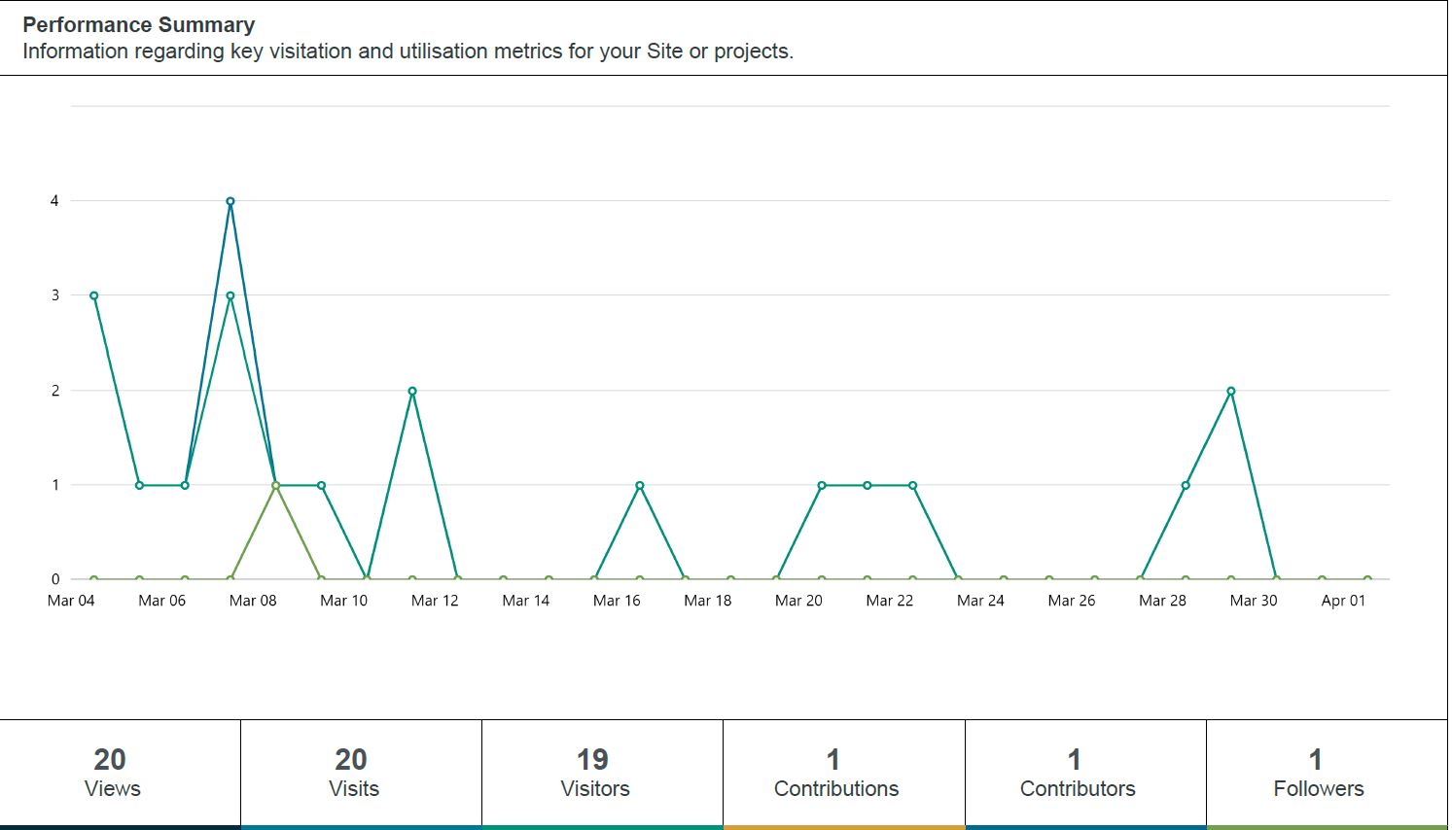
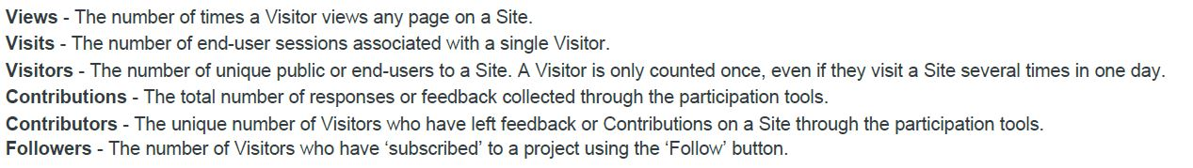
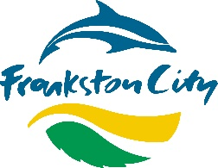
Quick Engagement Stats
Community Engagement was conducted online between 16 January 2023 and 10 February 2023.
81 people provided a response with 53% supporting the service continuing, 19% stating they were “unsure/don’t mind” and 28% not supporting the continuation of the service.
41 participants had not used an e-bike before, 11 had tried them but not continued to use the service, 25 were occasional users, and 4 were regular users.
We learned that participants chose not to try e-bikes as they preferred other forms of travel or owned their own bike. Those who had tried and discontinued using the service tended to do so for financial reasons.
When asking for suggestions to improve the service, these were the top five selections:
- Discounts for use (30 responses)
- More bike lanes in the service area (28 responses)
- More education on proper use and parking of e-bikes (25 responses)
- E-bikes at more locations/suburbs (24 responses)
- More designated parking areas (23 responses)

Engagement Report
Project Title
Review of the E-bike trial
Project Overview

Project overview
Council began a trial of e-bikes at the end of January 2022. Neuron Mobility own and maintain the 150 bikes included in the trial. Neuron also monitors how the bikes are used and moves the bikes around inside the trial zone for maximum benefit to the community.

Engagement purpose
This engagement was conducted to determine community support for continuing a peddle-assisted e-bike service in the City of Frankston. It was also used to understand what improvements community members would like for the service, to inform discussions with the current vendor (Neuron Mobility) when determining future improvements.

Community Consultation Process

Online engagement
Engagement on the E-bike trial was conducted online through Council’s Engage Frankston! Website.
The engagement opportunity was promoted through Council’s newspaper FCN with a reach of 60,000 households, the Mini Frankston e-newsletter, and an email campaign to 345 Engage Frankston subscribers.
Participants were presented with key information on the service, including the results from a customer service conducted by Neuron Mobility in September 2022.
Participants were provided with a link to Council’s Transparency Hub which provides detailed information about e-bike usage across Frankston City.
An online survey posed the following questions:
- What best describes your use of e-bikes?
- If the peddle assisted e-bikes continue, what would you like to see improved?
- Would you like the peddle assisted e-bike service to continue in City of Frankston?

Summary of outcomes
Community Outcomes
Following community engagement, Council has decided to continue the E-bike service with Neuron, with some modifications to the service:
- More designated e-bike parking areas. This aims to make use of designated parking areas more convenient for e-bike users.
- Introducing a financial surcharge for bikes left outside designated parking areas. This aims to encourage more consistent use of designated parking areas, with fewer bikes left in other places.
- Faster response time from Neuron to collect damaged bikes.
- At the end of 12 months Council will invite other e-bike operators to tend for a permit to operate in Frankston City.
- Considering community feedback, Council will consider the feasibility of expanding the agreement with Neuron to include e-scooters.

Recommendations & Next Steps
Recommendations
Considering the responses made by community and other stakeholders, the following recommendations are presented for consideration:
- That a peddle assisted e-bike service continues to operate in City of Frankston with some modifications.
- That Council invite other vendors into the e-bike rental market to provide residents with competitive prices
- That a future e-bike service provide additional designated parking areas and education to users on correct use and parking of e-bikes.
- That Frankston City Council continue to develop designated bike lanes and shared user paths in the e-bike service area.
- That the e-bike service area adapt to meet growing demand in other suburbs, as that demand emerges.

