Community Information
  - Orwil Reserve
Play space and park refurbishment


In September 2022, construction will start on a new play space and park refurbishment works at Orwil Reserve in Frankston.

About the project
Orwil Reserve is located on the corner of Orwil Street and Cricklewood Avenue in Frankston. The Frankston City Council Play Strategy (2021) recommends that a new play space and overall park improvement work take place at Orwil Reserve as a priority.
Orwil Reserve was selected based on the age and condition of the existing play equipment and strategic considerations such as access to other play spaces, demand and demographic data.

Key features

Key features of the new play space and park refurbishment work include:
- Play equipment that caters for all age groups;
- New picnic and barbecue facilities;
- Shade sails;
- Nature play;
- Extensive tree planting;
- New paths and park fencing;
- New seating, bins and drinking fountain.

Work will also take place to improve play opportunities at the adjacent Orwil Street Community House.

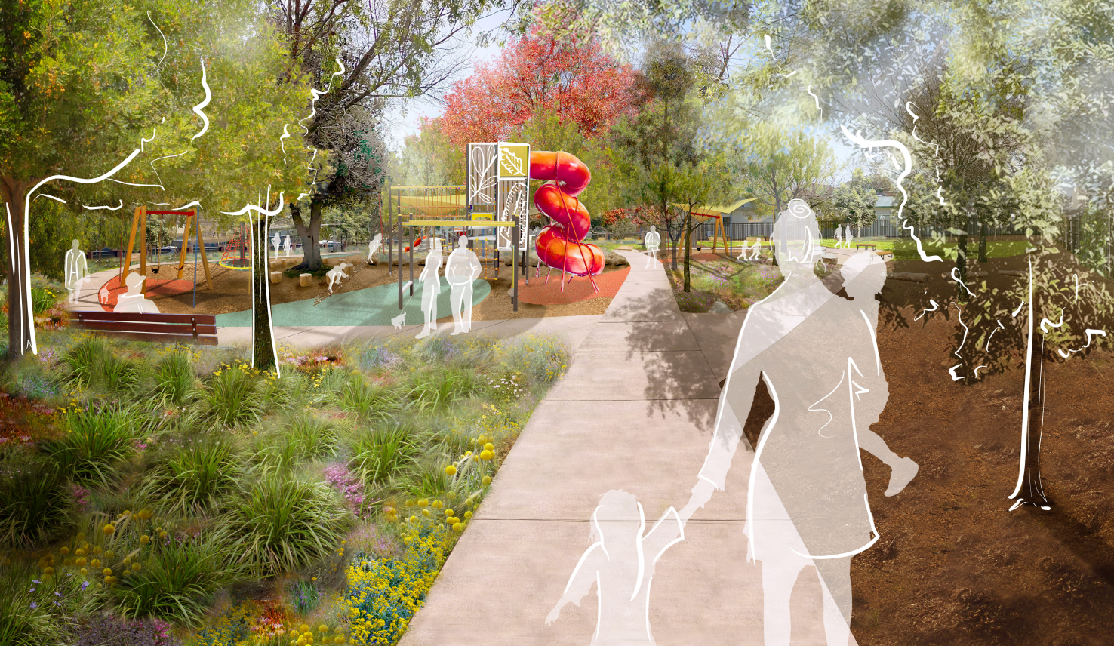

Artist’s impression of Orwil Reserve

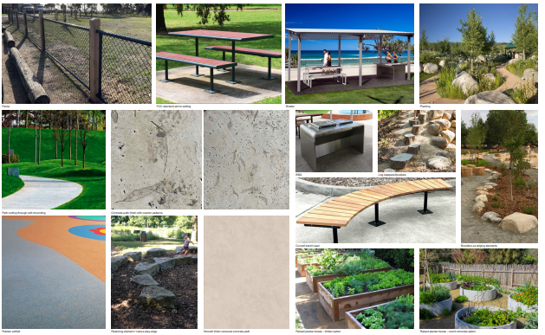

Park amenity - furniture, plants and trees

Construction

Construction is scheduled to start the week commencing 12 September, 2022. The park will be closed to the public during construction.

It is anticipated that construction will take approximately 12-weeks to complete – with the new play space opened in time for Christmas.

Construction activities may generate noise. We will ensure that works take place only between 7:30 a.m. and 5:00 p.m. on weekdays.

Thanks for your patience during construction.

For more information:
Please contact Steve Perumal, Coordinator Open Space, at the City of Frankston.

Email: steve.perumal@frankston.vic.gov.au
Phone: 1300 322 322

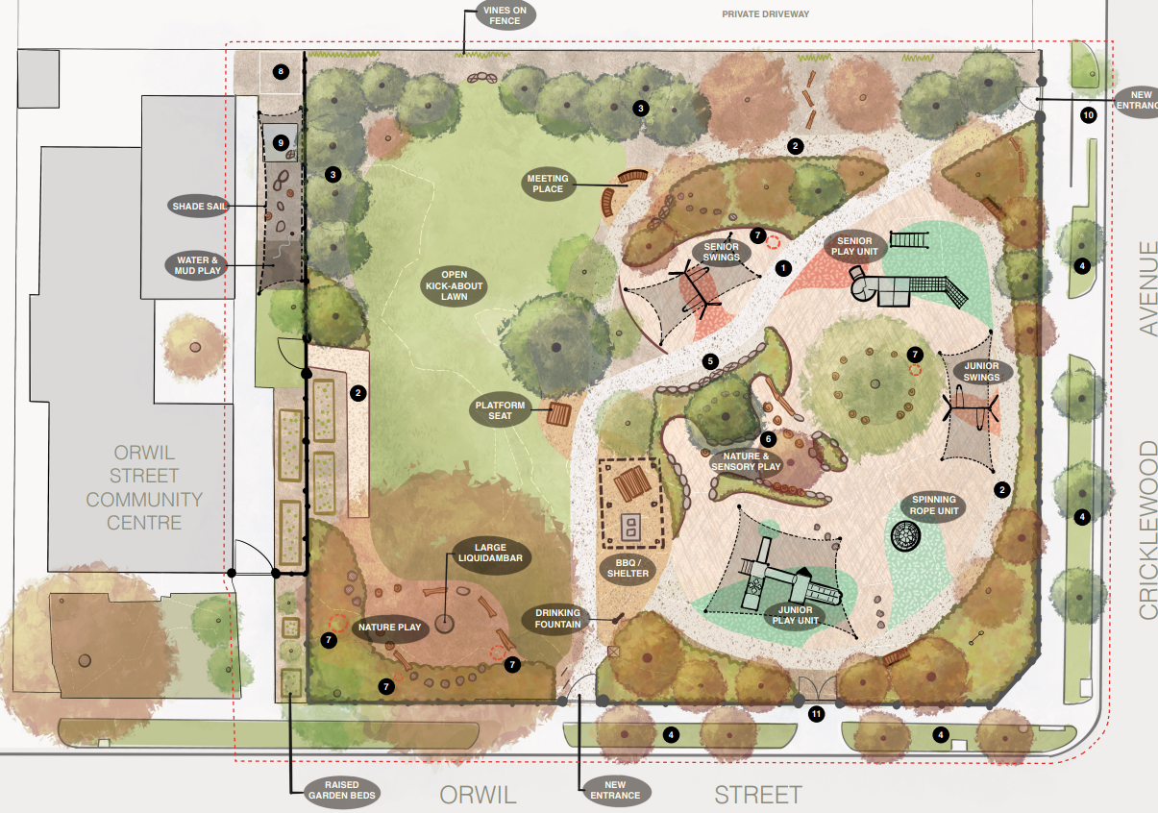

Landscape concept plan

