Reference: A4444502
Gould Street Upgrade Works Concept Design Project

<First Owner Name> <AND> <Second Owner Name>
<Address>
<Suburb.State>

Thursday 29 April 2021

Dear Sir / Madam

COMMUNITY PARTICIPATION – PLANNING FOR GOULD STREET UPGRADE WORKS

Gould Street Drainage Works and Pedestrian Access to Foreshore
As many of you may realise, the condition of infrastructure within the Gould Street precinct is aging and will require upgrade in the future.
Other concerns raised with Council relating to Gould Street concern what the future streetscape of Gould Street will be, considering drainage, paths, kerb and traffic.
Council has the responsibility as asset manager to ensure the precinct both meets the needs of residents and broader community in the short term, and also longer-term sustainability.
The Gould Street Precinct is located between the foreshore and Kananook Creek and stretches from Wells Street to Nepean Highway.
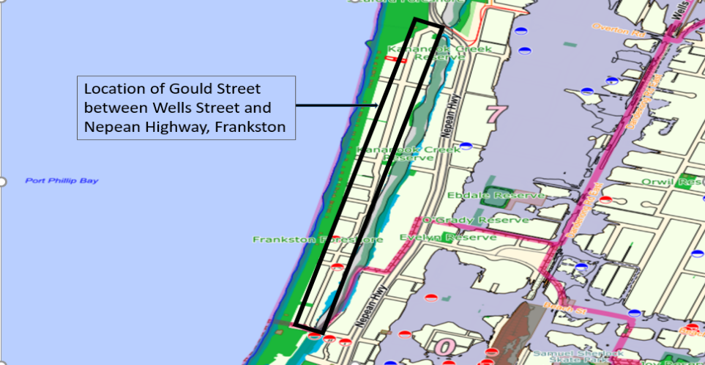

The Concept Design Process
We are calling first step in the planning process our ‘concept design process’. This involves:
- Identification of traffic, safety, access and drainage issues. Community members and residents can provide their input by reporting issues and concerns on these matters to the Council. The Council is also in the process of collecting and analysing data, together with information received from the community through enquiries and engagements with the Council.
- Following the identification of issues and inputs by the community, a draft ‘concept design’ will be developed.
- Following the community engagement on the design plan, we will amend the plan to respond to community feedback.
- Once we have a final plan, we can start an upgrade project primarily focused on accessibility to the foreshore and drainage issues on Gould Street. We will ensure the community are provided with information about how this project will occur.
Community Participation
Community participation is essential in identifying existing drainage and traffic issues in your local area, and there are multiple ways to contribute to outcomes of this assessment. Please note that due to the ongoing restrictions and uncertainty associated with Covid-19, different ways and means of communication would be pursued to ensure wider community involvement and consultation process.
All community members who have ideas, thoughts or concerns relating to traffic, road safety, pedestrian or cyclist issues, are strongly encouraged to get involved in one of the following ways:
- Provide your feedback and input on the foreshore accessibility review, Gould street drainage & traffic issues via Frankston Council Website/Social media platform (available on both PC and mobile) prior to 17th May 2021 via the link here:xxxxxxxxxx.
- Email us your feedback and return it to Frankston City Council’s Engineering Services Department by Monday 17th May 2021 using the enclosed ‘Reply Paid’ envelope or scanning and emailing to EngServices@frankston.vic.gov.au.
- Attend the Community Meeting, to be held at Council Room, Civic Centre at 6:30pm on Wednesday 19th May 2021. At the meeting you will have the opportunity to provide your input on local street issues and suggestions for improvements.

Should you have any queries or require further information in relation to the above, please contact Kizito Essuman, Infrastructure Engineer at Frankston City Council on 1300 322 322.
Yours faithfully,

Doug Dickins
MANAGER ENGINEERING SERVICES

