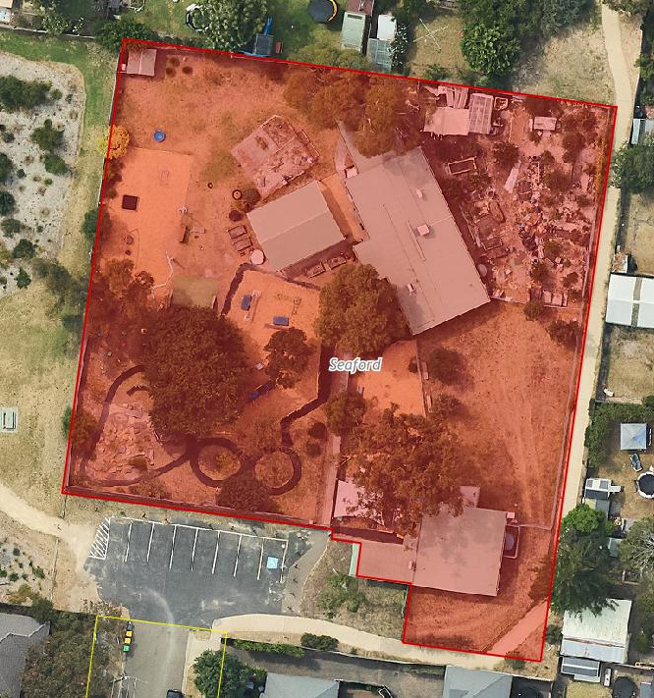
Outdoor play space
Kindergarten
Playgroup building
Food forest

