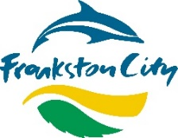
Quick Engagement Stats - 07/06/22 - 30/07/22

Project Title
Community Grants Panel
Engagement – Community Grants Panel
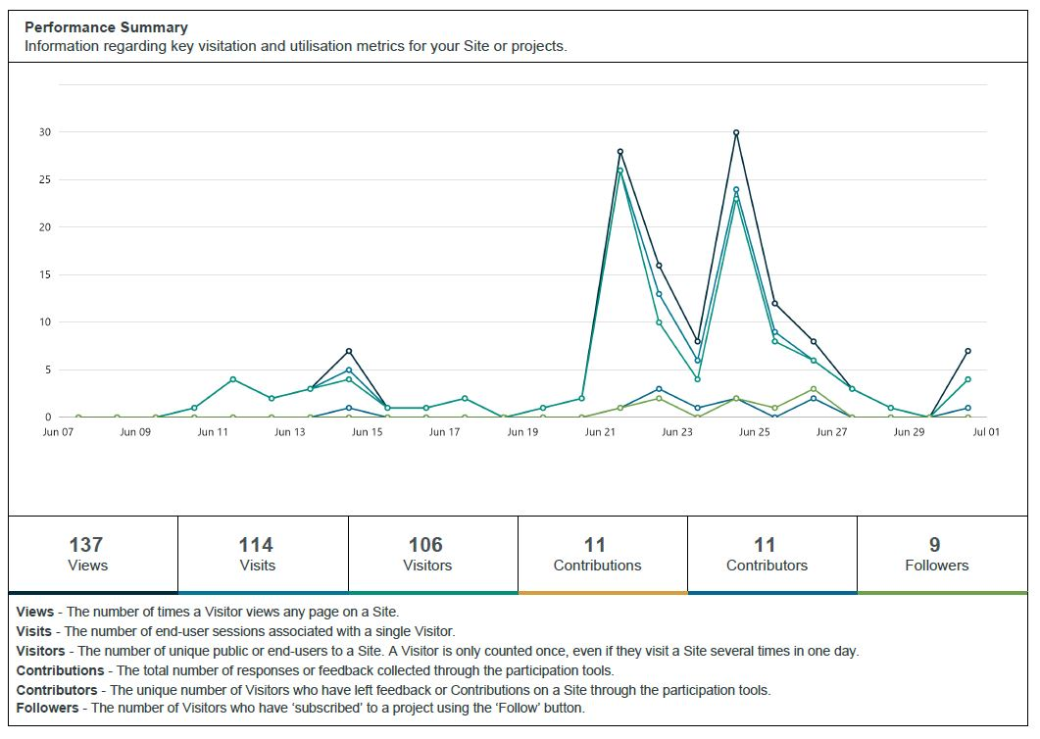
Project Overview

Project overview
At the Council Meeting on February 21, 2022 (CM2), Council endorsed "The establishment of a Community Grants Panel that includes community members, Councillor representatives and subject matter experts from within Council to support the assessment of the Annual Community Grants"
At the Council Meeting June 6 2022, Community Grants Panel was endorsed by Council with original endorsement amended to remove the Councillors from the assessment process.

Prior to this, delegated Councillors and Council Directors provided recommendations for the Annual Community Grants and approved the recommendations at a Council meeting.

Recommendations & Next Steps
Recommendations
The community representatives and their recommendations for the Annual Community Grants to be approved at the 29 October 2022 Council Meeting.

Next Steps
- Panel members deliberate recommendations for the Annual Community Grants on 13th September
- Present recommendations at the Councillor Briefing on the 19th September
- Present recommendations for approval at the 29 October Council meeting.
Community Consultation Process

Online engagement
Online engagement was conducted during the period 07/06/22 - 30/07/22 with the aim to seek expression of interest for the Community Grants Panel. 13 expression of interest applications were received, 11 through Engage platform and 2 sent through other avenues.

Stakeholder engagement
Mini Frankston City were notified of the opportunity to express their interest to be a part of the Community Grants Panel.

Summary of outcomes
Community Outcomes
The expression of interest applications received during the online engagement period were reviewed against the selection criteria. The selection panel then shortlisted applicants and interviewed them.
As a result, four applicants were successful in obtaining a community representative role in the Grants Panel for FY 2022-23. Community Representatives were officially inducted on 7 September 2022. Unsuccessful applicants were also notified.

o

