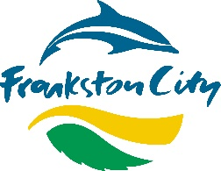
Quick Engagement Stats

Engagement - Report Back on a page
Project Title

Draft Development and Planting within Road Reserve Guidelines



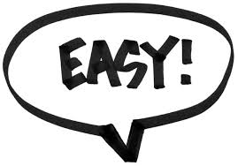

111 Contributions
109 Contributors
74.5%
of submissions supported the changes
83%
find the guidelines easy to follow
48.6%
plan to apply for a permit under the new guidelines/application process follow

Project Overview

Project overview
In accordance with a Notice of Motion (NOM) moved by Councillors earlier this year, we are reviewing the 'Development and Planting within Road Reserve Guidelines’ and application process to promote a greener and healthier Frankston. The new guideline is focused on:
• improving ease of use/understanding of guidelines.
• reviewing the permit fee.
• promoting stronger focus on planting nature strips for positive biodiversity outcomes (such as indigenous/native plants).

Engagement purpose
Ensuring that the updated guidelines meet community expectations and are clear and easily understood.

Of the 48.6% of contributors who indicated that they would be applying for a permit.
50.98% stated that they wished to do so to, ‘Support local biodiversity’ and 33.33% wishing to ‘Beautify my streetscape’.

Community Consultation Process

In-person engagement
- Nil

Online engagement
- Engage Frankston platform – online for approximately 3 weeks, 100+ respondents to survey questions. Promoted via social media and community networks (Gardens for Wildlife, Frankston Environmental Friends Network etc.)

Stakeholder engagement
- Engineering services (internal) – involved in reviewing and updating guidelines
- Operations (internal) - involved in reviewing and updating guidelines
- Environmental Planning and Policy (internal) – lead development of updated guidelines
- Gardens for Wildlife (external) – instigated review and contributed throughout

Recommendations & Next Steps
Recommendations
- Guidelines were Not adopted in 06 December 2021 meeting

Next Steps
- The current 'Development and Planting within Road Reserve Guidelines’ is still in effect.

Summary of outcomes
Community Outcomes
Key changes made based on community feedback:
- Reducing kerb setback from 1m to 600mm
- Planting height across nature strip to be 500mm maximum amended from 300mm outer edge and 600mm centre plantings
- Removing the requirement to supply a plan/sketch of the planting area with the permit application

Stakeholder Outcomes
- Agreement to remove permit application fee
- Reviewed and updated existing guidelines with new format, graphics and revised content
- Production of report to Council recommending adoption of revised guidelines for 06 December 2021 meeting.

