Suburban parks are important to all of us. They are where families create memories and where we connect with nature and each other. Suburban parks provide habitat for our native plants and animals, support healthy rivers and creeks, and help us tackle climate change.
The Victorian Government is investing $154 million in the Suburban Parks Program. It will create more than 6,500 hectares of new and upgraded parks and trails across Melbourne’s growing outer suburbs. The Department of Environment, Land, Water and Planning (DELWP) leads this program.
Why create new parks?
- to improve health and wellbeing
- to protect nature
- to strengthen cultural heritage
- to address climate change
- to attract jobs, investment, skilled people, and visitors to Melbourne’s growing outer suburbs.

What is the Seaford Wetlands Rejuvenation project?

In 2018, the Victorian Government committed to a $5 million package of landscaping and environmental works, with upgrades to walking paths and facilities in Seaford Wetlands.

Seaford Wetlands is listed as an internationally significant wetland under the Ramsar Convention for supporting important habitat for birdlife, including rare and endangered migratory birds.

The wetlands were once part of the extensive Carrum Carrum Swamp. The remaining 158-hectare remnant wetland is one of the largest natural wetlands in Port Phillip and Western Port Basins.

Seaford Wetlands is named in the Boon Wurrung language as ‘Lowyeeung’ and has unique cultural heritage values to the Bunurong People. As part of the project a self-guided biocultural trail will complete a loop around the wetlands and rejuvenate significant cultural knowledge and practices identified by Bunurong Elders.
Seaford Wetlands is jointly owned and managed by Frankston City Council and Melbourne Water.

Community consultation on proposed upgrades for the wetlands is planned for early 2022.

Location
Seaford Wetlands sits in the traditional lands of the Bunurong People in Seaford, approximately 52 kilometres south-east of Melbourne’s CBD.

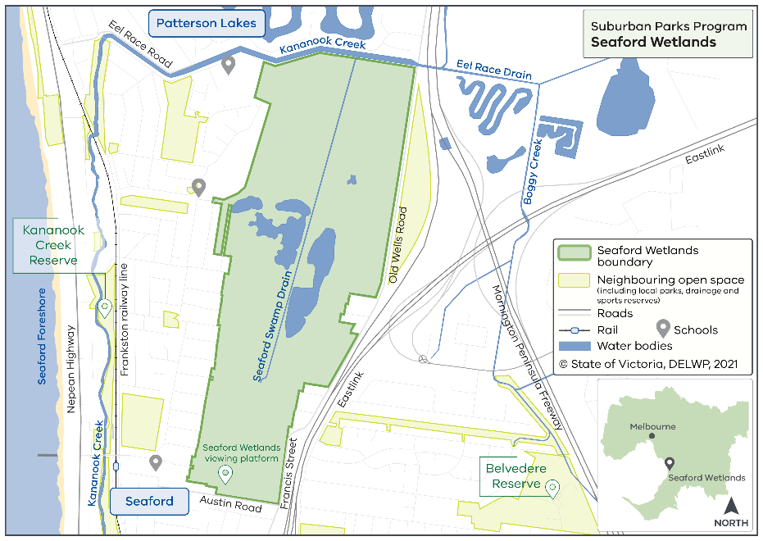

When will the park be open?
You can visit Seaford Wetlands now. We will open upgraded sections of the wetlands in stages.

Project partners and stakeholders

More information
Updates on the Suburban Parks Program are available online. Or you can email the Suburban Parks Program.


The State of Victoria Department of Environment, Land, Water and Planning 2022

This work is licensed under a Creative Commons Attribution 4.0 International licence. To view a copy of this licence, visit http://creativecommons.org/licenses/by/4.0/. ISBN 978-1-76105-465-5 (print). Disclaimer: This publication may be of assistance to you but the State of Victoria and its employees do not guarantee that the publication is without flaw of any kind or is wholly appropriate for your particular purposes and therefore disclaims all liability for any error, loss or other consequence which may arise from you relying on any information in this publication. All photos © Parks Victoria.
Accessibility: If you would like to receive this publication in an alternative format please email metro.parkland@delwp.vic.gov.au.
We are collaborating with:
- Bunurong Land Council Aboriginal Corporation
- Frankston City Council
- Kingston City Council
- Melbourne Water
- Local communities

