
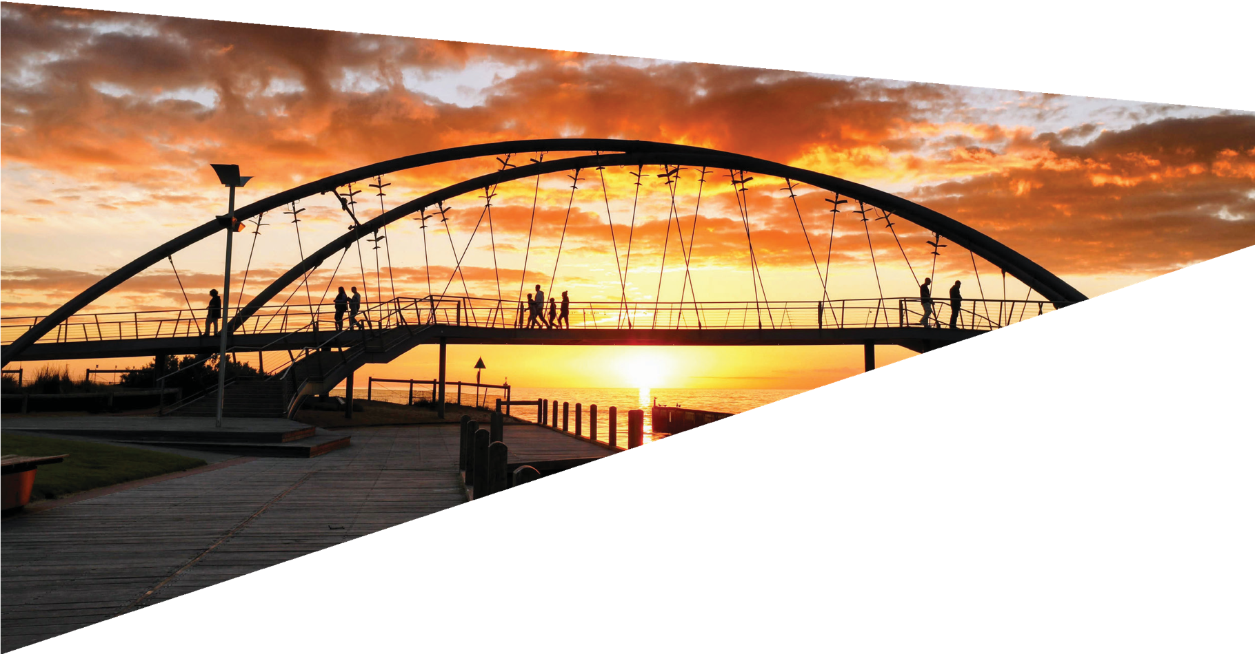
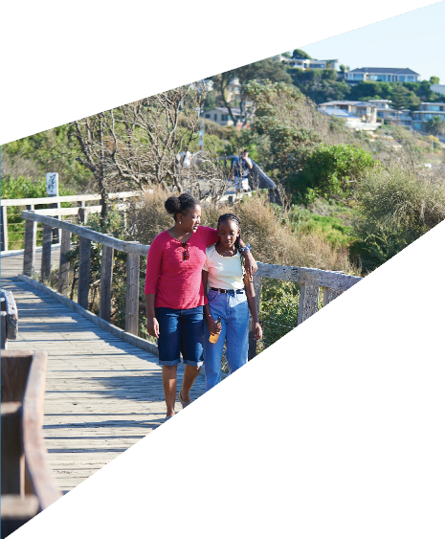
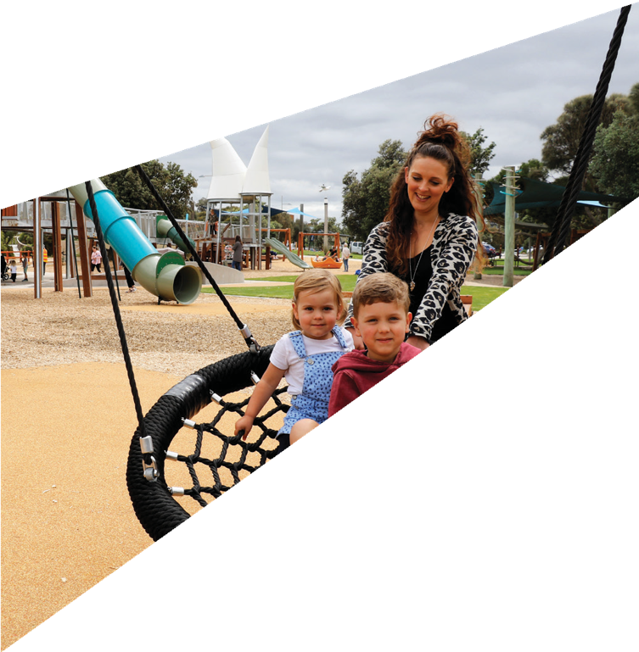

Frankston City Council
Asset Plan (Draft)
2023-2032

Table of Contents

Table of Contents 2
Acknowledgement of Country 3
1 Introduction 4
1.1 What is Asset Management 4
1.2 What is Council’s role in managing community assets? 4
1.3 The purpose of Asset Plan 5
1.4 Scope of the Asset Plan 5
2 Strategic Context 6
2.1 The Community Vision 6
2.2 The Council Plan 7
2.3 How do the City’s Assets Support the Delivery of the Community Vision and Council Plan? 7
2.4 The Financial Plan 9
2.5 Long Term Infrastructure Plan 9
2.6 Relevant Strategic Documents 9
3 Challenges and Opportunities 11
4 Community Engagement Outcomes 13
4.1 What is working well 13
4.2 Areas for improvement 14
4.3 Which assets are most important to the community? 14
4.4 Community led decision making principles 15
5 Our Assets 16
6 How Do We Manage Our Assets? 17
6.1 Asset Management Framework 17
6.2 Asset Lifecycle Management 18
6.3 Asset Lifecycle Phases 18
6.4 Asset Investment Strategy 19
6.5 Asset Investment Categories 20
7 State of Our Assets 21
7.1 Buildings 21
7.2 Roads and Car Parks 23
7.3 Bridges and Pedestrian Structures 25
7.4 Pathways 27
7.5 Stormwater Drainage 29
7.6 Open Space Assets 31
8 Funding the Asset Plan 33
8.1 Funding Community Needs 33
8.2 Financial Projections 34
8.3 Financial Plan Integration 34
8.4 Total Expenditure 35
8.5 Financial and Performance Indicators 36

Figures
Figure 1 - Our Integrated Planning and Reporting Framework 6
Figure 2 – Strategic Alignment of Assets to Community Vision, Council Plan, Services and Programs 8
Figure 3 – Frankston City Asset Challenges and Opportunities 11
Figure 4 - Assets and services that are working well 13
Figure 5 - Assets and services that could serve the community better 14
Figure 6 – Assets in order of importance to the community 14
Figure 7 – Frankston City Council Asset Management System / Framework 17
Figure 8 – Frankston City Council’s Asset Lifecycle Approach 18
Figure 9 – Community developed principles in action 33
Figure 10 – Asset renewal funding forecast 34
Figure 11 - Forecast Total Asset Expenditure 35
Figure 12 - Forecast Total Asset Expenditure over 10 years by Expenditure Category 35

Tables
Table 1 - Summary of Key Challenges and Opportunities 12
Table 2 – Community Identified Asset Priority Areas 15
Table 3 - Asset Summary 16
Table 4 – Asset Management Planning Documents 18
Table 5 – Approach to each Asset Lifecycle Phase 19
Table 6 - Expenditure Categories 20
Table 7 - Forecast Expenditure by Asset Class 35
Table 8 – Asset Management Financial Performance Indicators 36

Acknowledgement of Country

Frankston City Council acknowledges the Bunurong people of the Kulin Nation as the Traditional Custodians of the lands and waters in and around Frankston City, and value and recognise local Aboriginal and Torres Strait Islander cultures, heritage, and connection to land as a proud part of a shared identity for Frankston City.

Council pays respect to Elders past and present and recognises their importance in maintaining knowledge, traditions, and culture in our community. Council also respectfully acknowledges the Bunurong Land Council as the Registered Aboriginal Party responsible for managing the Aboriginal cultural heritage of the land and
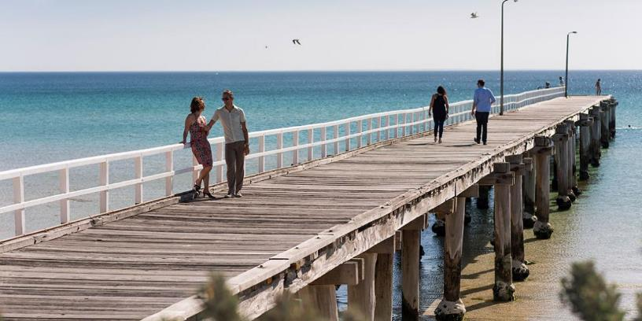
waters where Frankston City Council is situated.

Introduction

Supporting our vibrant city are Council managed infrastructure assets such as local roads, footpaths, stormwater drains, playgrounds, public lighting, library and community buildings and recreation centres. The city has many natural assets such as the Seaford Wetlands, foreshore areas, natural bushland reserves and open space and parks. Both infrastructure and natural assets are covered by this Asset Plan.
Frankston City Council is responsible for the stewardship of these assets for the benefit of current and future generations. As custodian of community assets, we have the responsibility for managing these assets in the most cost-effective manner. This is achieved through managing our assets through their lifecycle from creation and acquisition to maintenance and operation, through to rehabilitation and disposal.
Millions of dollars are spent annually managing and maintaining these assets. It is therefore important that Council employs sound asset management practices to ensure all Council assets are managed prudently and efficiently. The Local Government Act 2020 requires all Councils to develop a 10-year Asset Plan which is integrated with Community Vision and Council Plan.

This Asset Plan provides an avenue to communicate the importance and magnitude of the assets for which Council is responsible for and outlines the way we manage our community’s assets to support delivery of services. It provides a 10-year strategic and financial view of the assets that we own and control and how they will integrate with Frankston Vision 2040 and Frankston City Council Plan.

What is Asset Management

Assets support the delivery of services to the community. The practice of “asset management” refers to the range of supporting activities that monitor and maintain physical assets. These activities cover practices such as planning for an asset, asset inspections and maintenance, replacement, renewal, upgrade or expansion of an asset and disposal of an asset when it is not required any longer, amongst many more.

Asset management is a structured approach to aligning strategic planning with assets and service delivery. It answers the following fundamental questions:

- What assets does the community need now and in the future?
- How can we best manage the assets to serve the community?

What is Council’s role in managing community assets?

We manage a portfolio of assets that have a combined value of $1.55 billion. These assets have been established and invested in progressively over many years, by multiple generations. The standard to which our assets are maintained and the extent to which they are improved are a key consideration in setting and delivering on our Community Vision and Council Plan. Without these assets we could not provide our diverse range of services to the quality that our community expects now and into the future.

Assets also require ongoing management to relevant statutory/ regulatory requirements and to ensure they remain safe and serviceable for public use. These are key considerations in Council’s stewardship and management of city assets. Asset management also helps us plan for and delivery to the current and future needs of the community.

The purpose of Asset Plan

The purpose of this Asset Plan is to:
- Ensure that assets support the achievement of the Frankston City Vision 2040 and Council Plan themes and objectives
- Demonstrate we will responsibly manage our assets to meet the service delivery needs of our community into the future in a cost-effective way
- Provide a method to integrate our asset management planning outcomes with our Council Plan, Long Term Financial Plan and Budget
- Support the continued advocacy for Federal and State Government support for the expansion and upgrade of Frankston community assets
- Ensure we comply with our asset statutory and legislative obligations
This Asset Plan has been prepared to meet the requirements of section 92 of the Local Government Act 2020.

It is a general overview document that summarises the key elements of our individual Asset Management Plans that we have developed for each of our major asset classes.

Scope of the Asset Plan

While we manage an extensive portfolio of assets, this Asset Plan focuses on physical infrastructure that is under the control and is recognised as an asset of the Frankston City Council. Our physical infrastructure assets include:

 | Buildings and Facilities
 | Roads and Car Parks
 | Bridges, Major Culverts and Pedestrian Structures
 | Pathways
 | Stormwater Drainage Assets
 | Open Space and Natural Assets

Strategic Context

The Local Government Act 2020 requires all councils to develop an integrated, longer-term, and transparent approach to planning, organised around a ten (10) year community vision. This Asset Plan is an important part of our integrated planning framework, which is illustrated in the following diagram.

The golden thread which runs through all key documents aims to integrate key strategic plans across Council, along with regular community engagement and performance reporting. This includes our Asset Plan.

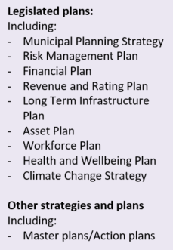
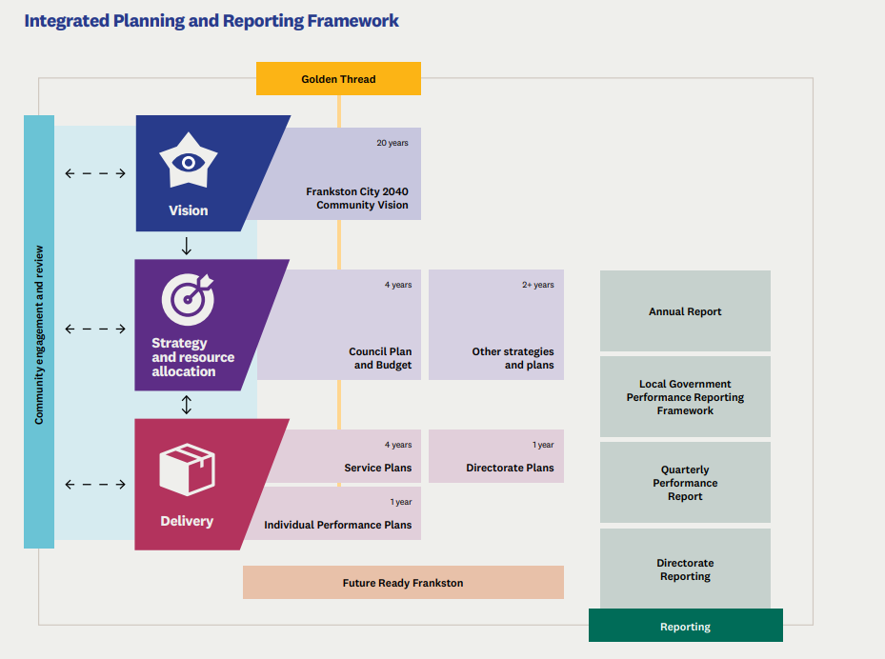
Figure 1 - Our Integrated Planning and Reporting Framework

The Community Vision

Our Community Vision is a statement of our community’s goals and aspirations for the future. It considers where we are, where we want to be and how will we get there. The Community Vision has been developed as part of Frankston City Community Vision 2040.

The themes identified in the Community Vision guide our Council Plan which sets out our strategic directions over the next four (4) years to achieve the long-term aspirations and goals of our community. The key themes outlined in the Community Vision have been related to relevant assets which will support the achievement of these themes.

The Council Plan

Our Council Plan makes a commitment to outcomes and priority initiatives across a number of strategic objectives which align to the Community Vision themes. Effective asset management supports the outcomes of the Council Plan and the delivery of sustainable services and programs. We recognise our stewardship role in appropriately managing the assets we have and aim to fulfil our obligations to future communities to provide sustainable assets and services.

How do the City’s Assets Support the Delivery of the Community Vision and Council Plan?

Infrastructure assets play a critical role in the delivery of the City’s goals and outcomes identified in the Community Vision and Council Plan. They support the delivery of services such as sport and recreation, transport, and community health. Physical assets provide places and networks which are the backbone of the delivery of services to the community. Without fit for purpose and well managed assets, the delivery of services can suffer or diminish.

The alignment of the Community Vision Themes, Council Plan Outcomes, City Services and Programs and infrastructure assets is shown in Figure 2. At a high level, it demonstrates how our community assets support outcomes and objectives.
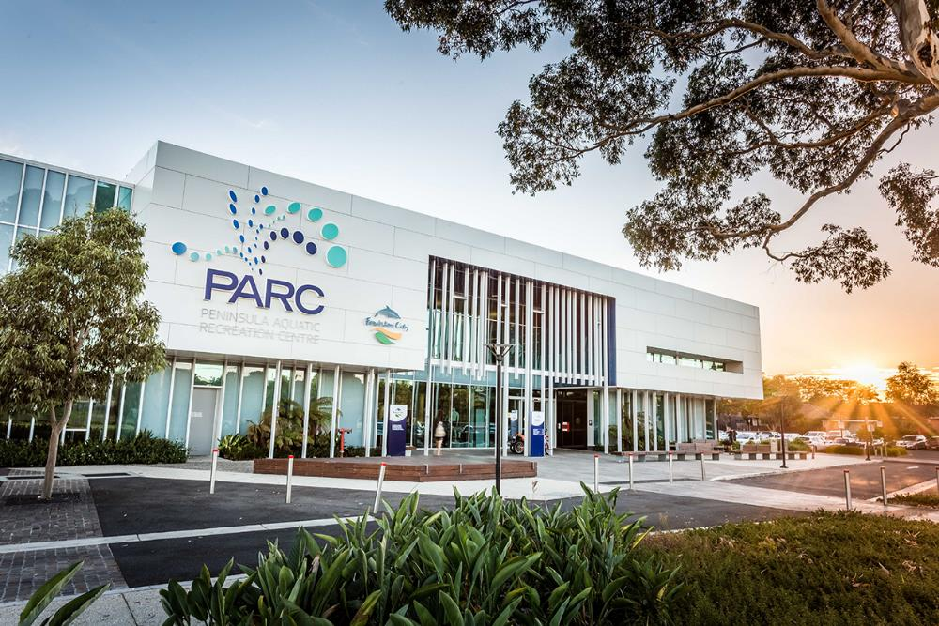

Vision 2040 Theme | Vision Theme Statement | Council Plan Outcome | Asset related Council Services and Programs | Assets Classes which Support Services and Programs |  | Specific Asset Examples | How
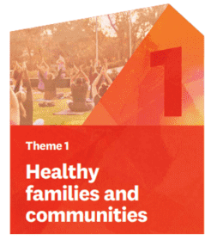 | Healthy families and communities  Empowering everyone to improve their health and wellbeing through access to green space, quality health services, social supports, education and opportunities to be physically active. |  | - Community Health  - Sport and Recreation  - Arts and Culture  - Community Development |    | - Buildings and Facilities  - Open Space Assets | - Arts and Cultural Facilities  - Child and Maternal Health Centres  - Community Centres and Halls  - Family and Youth Centres  - Neighbourhood Houses  - Sport and Recreation Facilities  - Sports fields, Play Surfaces and Sporting Infrastructure  - Play Spaces | Buildings and facilities provide spaces for health services, social support, education arts and culture and active recreation.  Parks, open space and sporting facility assets provide active and passive areas for physical activity throughout the city.
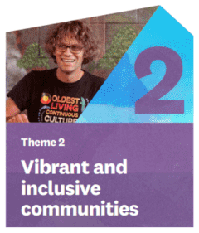 | Vibrant and inclusive communities  The community is proud of First Nations Peoples heritage and culture and promotes a sense of pride and belonging for the local Aboriginal and Torres Strait Islander community. Frankston City is known as a cultural hub with a thriving arts community, embracing diversity and promoting wellbeing. |  | - Arts and Culture  - Community Development  - Community Health |  | - Buildings and Facilities | - Arts and Cultural Facilities  - Child and Maternal Health Centres  - Community Centres and Halls  - Family and Youth Centres  - Neighbourhood Houses  - Urban Precincts/ Malls | Buildings and facilities provide spaces for arts and culture programs, libraries, community meetings and activities. Youth facilities and child and family centres provide spaces for community health services.  Urban/ shopping precincts and malls provide spaces for arts, cultural and community programs, events and initiatives to be run.
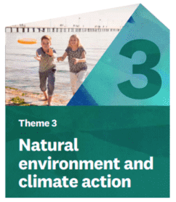 | Natural environment and climate action  Frankston City is green and sustainable, and a leader in sustainable industry and development. Both Council and community are committed to protecting and enhancing the environment and actively addressing climate change. |  | - Biodiversity and Open Space  - Integrated Water  - Waste and Recycling |    | - Open Space Assets  - Stormwater Drainage  - Buildings and Facilities | - Open Space / Parks  - Natural/ Bushland Reserves  - Foreshore and Seaford Wetlands  - Street Trees  - Streetscapes  - Park Furniture  - Stormwater Drains, Pipes and Pits  - Water Sensitive Assets (Rainwater Harvesting, Sediment Basins)  - Frankston Regional Recycling and Recovery Centre | Parks, open space, bushland reserves, the foreshore and Seaford wetland assets provide areas for the protection of biodiversity and the environment. They actively support efforts to address climate change.  The stormwater drainage network and water sensitive assets support the treatment of stormwater runoff prior to entering the bay. Stormwater harvesting assets also reduce the demand on drinking water for irrigation and other uses.
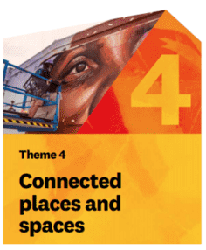 | Connected places and spaces  Frankston City is a well-connected and safe community with a unique identity, recognised for its vibrant City Centre that capitalises on its natural assets and heritage. Frankston City is the place that people want to visit, study, work and live in. |  | - Transport Connectivity  - Parking  - Urban Revitalisation (Public Spaces) |      | - Roads and Car Parks  - Bridges and Pedestrian Structures  - Pathways  - Open Space Assets | - Local Roads and Kerbs  - Bridges  - Pedestrian Structures  - Footpaths and Shared Paths  - Off Street Car Parks  - Open Space / Parks  - Natural/ Bushland Reserves  - Foreshore and Seaford Wetlands  - Street Trees  - Streetscapes | Local roads, bridges and pathways provide an extensive transport network to keep the community connected.  Open space, bushland reserves and the foreshore provide places for people to visit and recreate.  Car parks and urban/ shopping precincts provide spaces for people to access and visit.
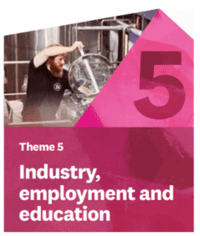 | Industry, employment, and education  Frankston City nurtures and attracts innovation and investment and is known for its education and business opportunities, including renewable energy, technology, hospitality, health and tourism. |  | - Arts and Culture  - Urban Revitalisation (Public Spaces) |    | - Buildings and Facilities  - Open Space Assets  - Roads and Car Parks | - Cultural Facilities  - Street Trees  - Streetscapes  - Open space reserves  - Park Infrastructure  - Urban Precincts/ Malls  - Metered Public Lighting in public | Buildings and facilities provide spaces for arts and culture programs, libraries, community meetings and activities. Youth facilities and child and family centres provide spaces for community health services.  Urban/ shopping precincts, malls and car parks provide spaces for urban revitalisation programs to be run from.
Figure 2 – Strategic Alignment of Assets to Community Vision, Council Plan, Services and Programs

The Financial Plan

The Financial Plan provides a long-term view of the resources that we expect to be available to us and how these will be allocated and prioritised over the next ten (10) years.

Our Financial Plan identifies our current and projected financial capacity to continue delivering high quality services, facilities and infrastructure, while identifying critical new capital investment to support our community’s prosperity and to respond to our future challenges. This Asset Plan is based on and inherently linked with the budgets and projections outlined in our Financial Plan. Ongoing affordability and financial sustainability are our key objectives. The Financial Plan in combination with the Asset Plan supports in achieving these objectives.

Long Term Infrastructure Plan

Frankston City Council’s Long Term Infrastructure Plan 2021‐2031 (LTIP) outlines Council’s approach to maintaining and improving assets over the next 10-year period. It includes information about how we develop, deliver and manage the LTIP including the long-term capital works program.

The LTIP is Council’s long term investment strategy for the city which seeks to:

- Grow the economy – enhancing the city’s capacity for long term economic growth
- Build communities – supporting a growing and diverse Frankston population
- Enhance the environment – managing and mitigating the impact on the environment; and
- Create a digital future for Frankston

The LTIP works hand in hand with the Asset Plan by outlining the specific asset projects and programs proposed to deliver on the strategic goals and objectives outlined in the Community Vision and Council Plan.

Relevant Strategic Documents

This Asset Plan supports several other strategic Council documents to achieve our long-term goals. These are listed below:

Asset Management Strategy | Integrated Transport Strategy
Open Space Strategy | Road Management Plan
Playground Strategy | Municipal Planning Strategy
Frankston South Drainage Strategy | Workforce Plan
Dandenong Road East Drainage Strategy | Health and Wellbeing Plan
Frankston Tip Management Strategy | Risk Management Plan
Municipal Signage Strategy | Future Ready Frankston (Corporate Strategy)

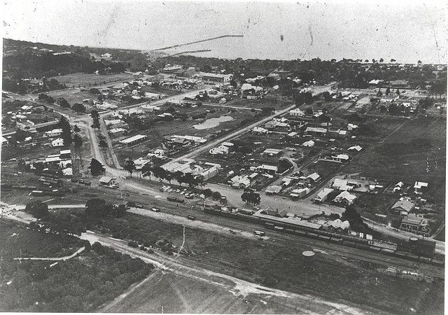

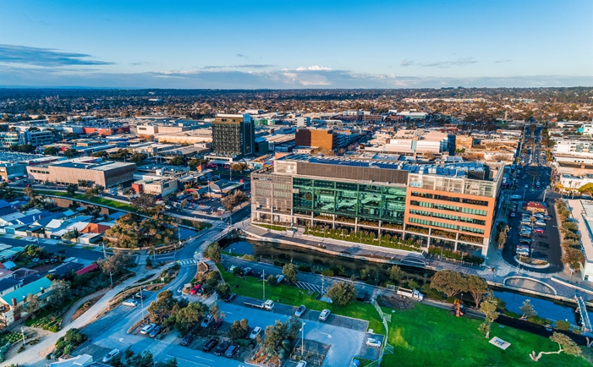
Source: Frankston City Libraries

Frankston circa 1922
Frankston today

Challenges and Opportunities

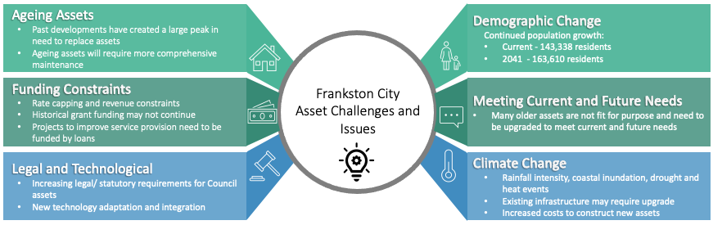
Figure 3 – Frankston City Asset Challenges and Opportunities
Challenge | What does this mean for asset management and service delivery?
Ageing Assets
One of the biggest financial challenges facing the City is the cost of renewing our steadily ageing infrastructure.  Much of Frankston City was developed and expanded through the 1960’s and 1970’s to today, with some older assets being constructed prior to this era. This period of development has created a large peak in the need to invest in asset maintenance and renewal. | As our assets continue to age, more investment in maintenance and renewal expenditure will be required to ensure that the current levels of service enjoyed by the community continue to be delivered. There is a need to continue to support asset management systems and processes in place to ensure that our spending on our existing assets is optimised and the performance of our assets is monitored.
Funding Constraints and Affordability
Frankston City has been and continues to be the beneficiary of significant sums of Federal and State government grant funding for the upgrade, expansion and creation of new assets for a growing community. Council, however, is experiencing a significant limitation on our own source revenue due to constraints such as rate capping.  Limitations or reduction of own source income due to rate capping could also have a material effect on Council’s financial sustainability.  Cost increases to items such as asset materials, supply, electricity, and fuel impact on Council. For the Council, this occurs with expectation of doing more with less or improving our efficiency over time. | Federal and State Government Grant schemes can reduce in size and veracity based on several external factors outside of our control. A slowdown in investment in new and upgraded assets may result from any tightening of grant schemes. This could force Council to fund only asset renewal and maintenance and limit expenditure on new or upgraded infrastructure.  This will impact the way we invest in our assets and services in the future. We will need to aim to continually balance the affordable provision of services against the needs of our community.
Legal and Policy Change
We operate in a complex legislative environment that directly influences the way manage our assets. Cost shifting from other levels of government will continue to play a key role in Council’s ability to maintain service level provided to the community.  There is an expectation that Council will continue to deliver services, even when State and Federal government funding is withdrawn or reduced. Asset related compliance and reporting requirements are expected to continue to increase and become more complex. | We need to meet our regulatory and statutory obligations while being conscious of maintaining affordability and financial sustainability. This requires good decisions to be made to manage competing funding demands across a broad range of projects, programs and services.
Technological Change
There is a significant move to online and connected services throughout the world. People, businesses, and governments are increasingly moving online to deliver and access services, obtain information and to perform day to day activities.  There is also significant change in technologies for the management of assets such as building and facility operational systems, asset inspection technology and performance monitoring devices. | We will have the capability to share our data on our assets to others, enabling them to interact with our services digitally. We will also be able to enable a more mobile workforce.  We should look to assess and, where appropriate, adopt and introduce new asset operational and management technologies to achieve efficiencies and potentially cost savings over the long term.
Demographic Change
Population projections indicate an expected 14% increase in population for Frankston Local Government Area over the next 20 years. This is an increase from 143,338 residents today to 163,610 residents in 2041. The growth is anticipated to settle predominantly in Frankston, Carrum, Seaford and Langwarrin areas.  Whilst all age brackets are expected to grow in number, the majority of the population growth will be in the 10-19 years and 60-85 years+ age demographics ranges. | We will need to expand our services and assets to cater for our growing community. Council will need to make a financial investment in infrastructure so that our assets are of a suitable capacity to cater for growth and that exemplary urban renewal is achieved.  A changing demographic will mean that we will need to adjust the provision of services to accommodate the changing demographics and maintain a focus on providing services that promote access and equity.
Meeting Current and Future Needs
The community expects Council to be able to quickly respond to emerging needs which can be influenced by numerous drivers such as generational change, legislation, environmental standards, facilities experienced elsewhere and new technology.  There is ongoing pressure from the community for higher quality assets and services to be provided for most Council activities. More advanced and functional buildings, enhanced open space areas, modern technology and convenience are some examples. The expectation is for a higher level of service for the same amount of money – in other words doing more with less. | We will need to plan assets that are responsive and adaptable to meet shifting community needs. We will continue to strongly advocate to other levels of government for support in meeting the current and future needs of the community.  We will look to form service delivery partnerships with organisations where appropriate for non-asset service delivery solutions in turn optimising the use of Council’s asset portfolio.  Our assets must cater for the expectations of the community by remaining accessible, well maintained, and fit for purpose. This must be balanced and prioritised against investment in new and expanded assets to support the City’s future and the ability of the community to pay.
Climate Change
We are already experiencing the impacts of climate change. In the future, we can expect; increased flooding of coastal properties and public facilities; storm damage to infrastructure; beach erosion; increased heat and drought conditions, reduced summer outdoor activities; and hotter urban spaces. | Changing weather may lead to increased need for reactive maintenance. Assets will need to be built and renewed to a standard that can withstand at least 1.5 degrees of temperature increase. This may require different materials, methods of asset construction and other innovative approaches.  There is also an increased expectation for leadership from Council to develop and implement long term strategies to address and adapt to climate change impacts. These could range from the use of sustainable energy sources to providing assets that are environmentally efficient, greening the city to reduce heat effects and building resilience into the drainage network to cope with severe storm events. In the medium term, there may be greater community demand for weather protection for sports and leisure activities that have traditionally occurred outdoors.
Table 1 - Summary of Key Challenges and Opportunities

Community Engagement Outcomes

This Asset Plan along with our Community Vision and Council Plan has been developed with input from our community via detailed deliberative engagement processes. A dedicated Frankston 10 Year Asset Plan Community Panel was established in early 2022 to discuss and identify the key principles by which Frankston City should prioritise and invest in its asset over the next 10 years. The community engagement was undertaken in March 2022 to engage and collaborative meaningfully in line with Local Government Act 2020 requirements, to inform the development of the Frankston 10 Year Asset Plan.

The diverse members of the Frankston 10 Year Asset Plan Community Panel reflected the broad Frankston community demography and they worked together to deliberate over this important question:

‘What are the key community assets that Frankston needs to focus on and/or improve, to deliver the required services over the next 10 years?’

In deliberating over this question, the panel identified a set of decision-making criteria (principles) and community recommendations for future allocation of discretionary funding and priorities for asset investment using the following questions:

- What are the most important assets to you?
- What assets are working well?
- What assets need further improvement?
- How should Council make decisions about asset management and planning (budget allocation and prioritising)?

The outcomes from this process have been incorporated into the Asset Plan and will guide Council decisions over the life of this Asset Plan.

What is working well

The panel provided responses to the question ‘what is working well?’. Some recurring themes arose and answers have been grouped in more than one theme:
 |  |  | 
Parks and Open Space | Natural environment and nature reserves | Playgrounds | Library services
 |  | 
Walking paths, trails and boardwalks |  | The foreshore (including foreshore trails)
Figure 4 - Assets and services that are working well

Areas for improvement

The panel provided responses to this question ‘what is not working well?’. Some recurring themes arose and answers have been grouped in more than one theme:

 |  |  |  |  | 
Traffic and Road Services | Disability access and parking |  | Parking |  | Waste and dumping management
 |  |  |  | 
Foreshore Facilities |  | Pedestrian amenity | Maternal health and Childcare | Environmental sustainability and protection
Figure 5 - Assets and services that could serve the community better

Which assets are most important to the community?

An asset survey was taken as part of the first and final panel sessions. The results show that natural assets including bushland, open space, foreshore and wetlands, trees and vegetation are the most important assets for the community, with local roads and public lighting also receiving a high response.

Some participant’s referred to an increased understanding and appreciation for managing the natural environment, stormwater and footpaths as reasons for their response.

 |  |  |  | 
1. Bushland and Nature Reserves | 2. Open Space and Parks | 3. Foreshore and Wetland | 4. Trees and Vegetation | 5. Local Roads
 |  |  |  | 
6. Public Lighting | 7. Arts and Library Facilities | 8. Pedestrian Structures | 9. Paths and Cycleways | 10. Stormwater Harvesting and Treatment
Figure 6 – Assets in order of importance to the community

Community led decision making principles

Four key priority areas (themes) were identified through the community deliberative engagement process and are shown below. These themes were used to develop asset decision-making principles for Council and the Community.

 |  |  | 
Public Space and Nature  Open spaces that are accessible to all members of the public | Connectivity and Accessibility  Assets that support connection and accessibility for a wide range of people | Sustainability/Climate Change Resilience  Assets that respond to and integrate climate change considerations and resilience | Facilities Meet Community Needs  Facilities and buildings to meet current and future community needs

The themes were used as a basis to develop specific principles to be used to guide Council asset prioritisation and investment decision making over the next 10 years. The community identified principles will guide future funding priorities and allocation. Integration of these principles into Council decision making is critical to ensure current and future community identified needs and priorities are met and is further outlined in the funding of this Asset Plan. The final principles and intended outcomes identified by the community panel are shown below.

Theme | Community Identified Principle | Community Identified Principle Outcomes
  Public Space and Nature | Promote and improve public space for optimal use and ensure spaces are equitably accessible across the municipality. | - Set an aspirational ratio that we’re looking for between public space: greenspace  - Managing/preventing conflicting uses and activities which may reduce enjoyment | - Provision of equitable access to green space  - Including corridors and large trees to increase our protection and enhancement of the natural environment
 | Increasing percentage of green space in public spaces.
  Connectivity and Accessibility | Provide, maintain and advocate for infrastructure and services that enable all residents and visitors to move easily, safely and comfortably around the Municipality and surrounding areas. | - Improve the efficiency and accessibility of transport and connectivity  - Residents of all income levels and abilities would feel comfortable accessing the services  - Providing better services for the Community of Frankston City -transport & connectivity  - Development of key links in walking paths. Conduct survey throughout the Municipality  - More parking at the Frankston Library | - When working with developers, making real effort with sustainability  - Better storm water drainage  - Identify gaps in connectivity (missing paths) using technology to improve connectivity  - Pedestrian bridge from train station to TAFE and Parc  - Providing a seat at a bus stop  - Review of bike lanes and active transport infrastructure and better provisions for bike lanes
 | Efficient, accessible services and connections that are fit for purpose with the ability to adapt to current and future community needs, through the support of technologies and systems.
  Sustainability/  Climate Change resilience | Invest in the protection, enhancement and balance of the natural environment and wildlife to ensure sustainability for future generations | - Zero carbon emissions  - Electric cars, plant and equipment  - Creative and future facing technologies  - Flourishing flora and fauna and protection of endangered species  - Sustainable balance between natural and built environment  - Nature city -greening of the city | - Environmentally friendly playgrounds  - Increased recycling and stormwater, grey water reuse  - Clear definition for identifying uses of open spaces i.e., natural beauty area, sports fields, birdwatching areas, cycling park  - Six-star rating for new buildings
 | Invest in technologies and strategies that utilise sustainable energy and promote resilience to climate change.
  Facilities meet community needs | Invest in transparent information and community engagement to ensure the diversity of community needs are met now and in future to inform facility/asset design. | - Assist community members to interpret and understand facility design information and process information provided  - People (engaged) are well informed  - Facilities meet all of the principles  - Contributes to financial and environmental sustainability  - Appropriate subject matter experts are engaged at the right time and technical expertise is valued | - Reduction in complaints  - Less building or facility rework/ less redesign is needed  - Meeting individual needs  - Facilities meet needs now and into the future, already accounted for needs within design  - Diversity of participants  - Increase in accessing facilities and services  - Increase in engagement with community and individuals
 | Accessible, environmentally sustainable facilities that ensure safety and inclusivity throughout a community’s and individuals’ life.
Table 2 – Community Identified Asset Priority Areas

Our Assets

Our assets are valued at approximately $2.4 billion. This includes land, infrastructure assets and non-infrastructure assets.

Our infrastructure and non-infrastructure assets are valued at approximately $1.55 billion. Our assets are grouped in into the following key asset classes:
Asset Class |  | Quantity | Value ($ ‘000)
 | Buildings | 331 Buildings | $355,008
 | Roads & Car Parks | 706 km of Local Roads  134 Off‐Street Car Parks | $581,699
 | Bridges and Pedestrian Structures | 160 Bridges and Pedestrian Structures | $26,247
 | Pathways | 996 km of Pathways (Footpaths, Cycleways and Shared Paths) | $125,695
 | Stormwater Drainage | 950 km Stormwater Drains  40,718 Stormwater Management Pits | $291,495
 | Open Space | 525 Open space reserves  70 Natural Reserves  165 Playgrounds  11km of Foreshore  78,000 Street Trees  137 Sportsgrounds | $134,795
 | Waste Management | Waste Bins and Frankston Regional Recycling and Recovery Centre Assets | $2,950
 | Plant, Furniture and Equipment | Council Plant and Machinery, Office Furniture, Equipment ICT Assets | $36,076
 | TOTAL |  | $1,553,964
Table 3 - Asset Summary

How Do We Manage Our Assets?
“As stewards of community assets, Frankston City Council will provide assets that support the provision of best value services. Council assets will be accessible, safe and suitable for community use. The approach to asset management will be sustainable. It will balance competing community social, environmental and economic needs for the benefit of current and future generations.”

Asset Management Framework

The Asset Management Framework illustrates the relationship between Council’s strategic objectives and asset planning at the strategic, tactical, and operational levels. This Framework aims to ensure that a systematic approach to asset management delivers prudent and efficient outcomes to meet both our community and asset management objectives.

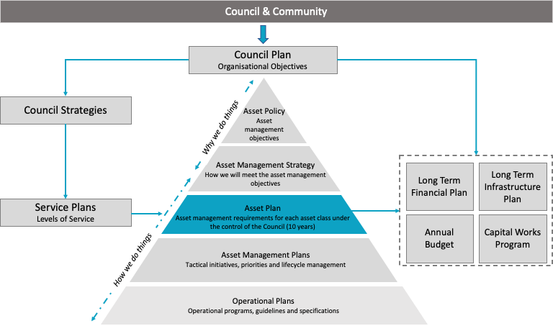
Figure 7 – Frankston City Council Asset Management System / Framework
Document | What does this mean for asset management and service delivery?
Asset Management Policy | The Asset Management Policy summarises the vision and objectives for asset management. The Policy outlines responsibilities for asset management across the organisation and recognises that asset management is a collective responsibility. The objectives can only be achieved if all parties responsible work together to achieve the vision.
Asset Management Strategy | The Asset Management Strategy outlines how we will deliver our Asset Management Policy intentions. The purpose of this Strategy is to provide the framework for the ongoing enhancement of Council’s asset management practices to deliver sustainable and effective services, support the implementation of the Asset Management Policy and to achieve organisational objectives.
Asset Plan | The Asset Plan provides a high level 10-year view of Council’s priorities around maintenance, renewal, acquisition, expansion, upgrade and disposal of infrastructure and how these are to be integrated within Council’s decision-making process and financial plans.  The plan relates outcomes from community deliberative engagement to guide Council asset decisions, needs and activities over the next 10 years.
Asset Management Plans | Our Asset Management Plans provide information on how we intend to manage each of our asset classes to meet the demands of our community in the future. They provide the roadmap for achieving value from our assets by optimising cost, risk, and performance across the lifecycle of an asset.  We currently have Asset Management Plans for Roads, Pathways, Stormwater Drainage, Buildings and Open Space Assets.
Operational Plans | Our Operational Asset Plans provide information on how we manage our assets at an operational level. They cover aspects such as asset maintenance and inspections frequencies and details, asset condition assessment and operational procedures for complex assets. They aim to provide guidance and structure to the operations of assets and ensure that these operations are consistent with the overall lifecycle management strategy of an asset.
Table 4 – Asset Management Planning Documents

Asset Lifecycle Management

The City takes a formal approach to the lifecycle management of our assets. This ensures we optimise our management practices at each phase in an asset’s lifecycle and results in cost-effective asset management. Underpinning the above Framework are our asset risk management processes to support decision making through each lifecycle phase. The key stages in our asset lifecycle are shown below.
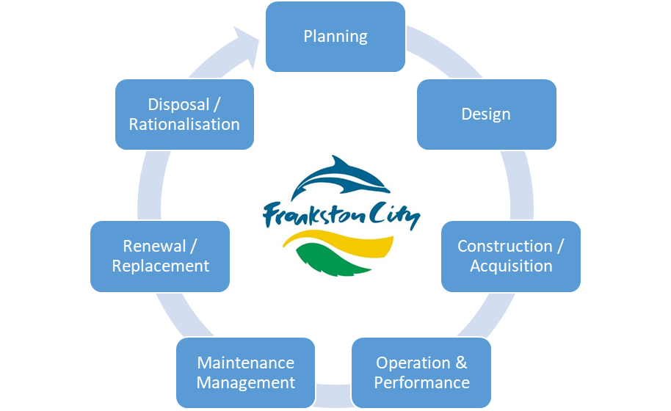
Figure 8 – Frankston City Council’s Asset Lifecycle Approach

Asset Lifecycle Phases

Each phase of the asset lifecycle requires different activities and strategies tailored to the asset type to manage cost, risk and performance of the assets. These are summarised in the table below.

Lifecycle Phase | Our Lifecycle Management Approach
Planning and Design | - Asset requirements are identified to meet service needs over the long term  - Asset design considers affordability, equity, maintainability and the environment  - Evidence based decision-making that considers the whole-of-life implications of acquiring, operating, maintaining, and disposing of an asset
Creation/ Acquisition | - Assets are constructed according to planning and design documentation  - Utilise effective procurement strategies for prudent and efficient delivery of assets  - Delivery of assets according to Council Project Delivery Framework  - Newly acquired assets are handed over, assessed for quality and accepted before they are put into service
Operations | - Consistent monitoring of existing assets’ operations over their useful life  - Systems and processes record information about assets  - Cyclic assessment of the condition of our assets over their life
Maintenance Management | - Regular inspections, servicing, and maintenance of our assets so that they are safe, compliant, and are continuously available for use.  - Maintenance is planned to minimise the risk of asset failure  - Optimisation of works and intervention to minimise ongoing costs
Renewal/ Replacement | - Optimisation of the timing of the renewal or replacement of each asset  - Maximise the use of our assets through reuse or co-location of services
Disposal or Rationalisation | - Where assets do not directly support service objectives they are considered for rationalisation or co-location with other assets to reduce lifecycle costs
Table 5 – Approach to each Asset Lifecycle Phase

Asset Investment Strategy

The next 10 years requires a significant investment in the City’s assets to maintain and renew these assets at optimal points in time and ensure public safety, continuity of service provided to the community, whilst minimising ongoing lifecycle asset costs. This investment in asset maintenance and renewal is to be balanced by significant investment in new and upgraded assets to meet current and future demand across the City as Frankston grows and evolves.

Prudent and efficient investment decisions using a holistic lifecycle approach to asset management have been applied in this Asset Plan and supporting practices. The integration of the Asset Plan and the Financial Plan is critical to ensure the resources required to manage assets to agreed levels of service are provided for, in a financially sustainable manner.

This Asset Investment Strategy aligns to the principles outlined in the Financial Plan, the decision-making principles developed via community engagement and our asset management objectives and covers the following:

- That Council seeks to make the right decisions about capital investment and asset management through the Asset Management Framework and alignment to the Integrated Planning and Reporting Framework
- That Council annually reviews the asset renewal gap and ensures adequate measures are in place to manage it
- That asset renewal cannot be funded by non-renewable funding sources such as asset sales, reserve funds or loan funds
- That Council seeks to prioritise renewal, compliance and maintenance work
- Asset co-location, rationalisation or disposal is considered (where appropriate) to minimise ongoing costs to the community to maintain existing assets.

Asset Investment Categories

For the purposes of this Asset Plan, our spending on our infrastructure is categorised in the table below. Classifying our expenditure in this way helps us to plan our budgets and track how we spend our money on our assets and services.

Expenditure Category | Activity | Description
Non-Discretionary Maintenance and Operations | Maintenance | Ongoing work required to keep an asset performing at the required level of service
Non-Discretionary Maintenance and Operations | Operations | Recurrent expenditure that is continuously required to provide a service
Non-Discretionary Renewal | Renewal | Returns the service potential or the life of the asset up to that which it had originally
Discretionary Growth | Upgrade | Enhancements to an existing asset to provide a higher level of service
Discretionary Growth | Expansion | Extends or expands an existing asset at the same standard as is currently enjoyed by residents, to a new group of users
Discretionary Growth | New | Creates a new asset that provides a service that does not currently exist
Table 6 - Expenditure Categories
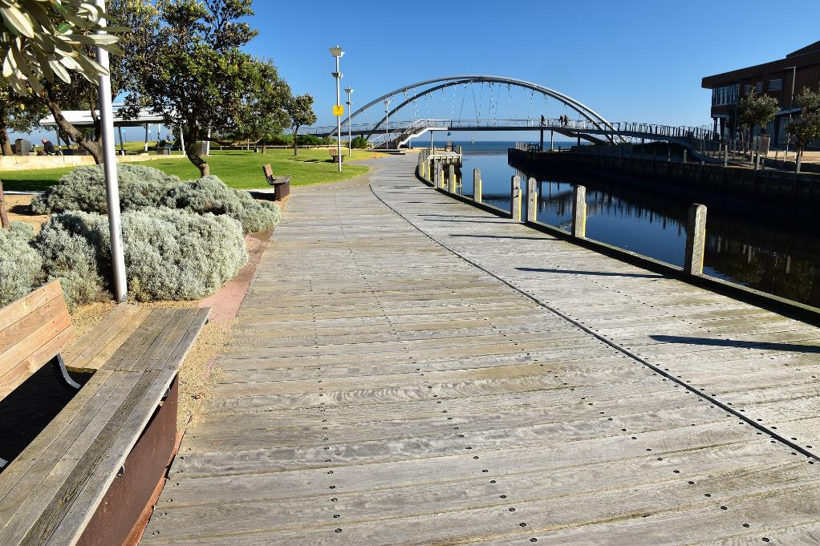

State of Our Assets

The following asset class summaries provide the current state, challenges, choices and projected expenditure requirements for each key asset class over the next 10 years. These funding requirements have been determined based on the key principles and outcomes from the deliberative community engagement, affordability assessments made in our Financial Plan and represent the investment that is required to maintain our existing levels of service provided to the community.

Buildings
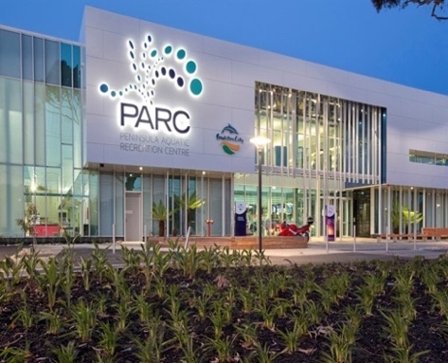 |  | Service | Provide buildings and facilities for Council services such as maternal and child health centres, arts and library facilities, sporting pavilions and change rooms, aquatic, gym and leisure centres, youth centres, kindergartens, childcare and public amenities.
 |  | Service Objective | Our buildings and facilities are safe, functional, fit for purpose, and accessible to all users.
Key Challenges and Choices
Ageing Buildings | Changing use of buildings and future needs |  |  | Building Technology
- Ageing buildings will require increased investment to ensure they are maintained in a safe condition into the future.  - Older buildings may be rationalised or co-located with other buildings to provide modern multi-purpose facilities whilst reducing ongoing maintenance costs. | - Some buildings will require upgrade to meet current day standards and requirements.  - Population growth may lead to increased demand for services supported by buildings requiring increased availability of functional space.  - Demand for accessible facilities can be expected to increase as the Frankston population continues to age. |  |  | - Advances in building operational technology could provide opportunities to improve operational efficiencies and reduce ongoing building lifecycle costs.  - Demand for on-line and other innovative service delivery approaches is increasing.  - Functionality of buildings is increasing as they become multi-purpose and are expected to support a range of co-located services.
Current Condition
The current condition of the building asset portfolio is considered good to fair with a small number of buildings in poor and very poor condition. These buildings have been priortised for full or part renewal in the forward capital works program.
Asset Performance Assessment
Current Performance |  |  | Fit for the Future?
The current porfolio of buildings is performing reasonably well given the age and standards to which some were constructed. Key facilities such as PARC, the Franskton Arts Centre and other sporting and community facilties have been upgraded and expanded to meet current and future demand. |  |  | Continued upgrade and expansion (and construction of new or multi-purpose buildings) is required over the forward 10 years to ensure that the building portfolio continues to support the delivery of a vast array of services. Key building upgrades required are focussed on the sports and recreation service area with contiuned high demand for netball, basketball and gymnasium facilties.

Relevant Asset Activities
Non-discretionary – Recurrent | Non-discretionary – Renewal | Discretionary – Growth
- Minor repairs to building components due to failure, vandalism, etc  - Unblocking gutters, floor covering repairs  - Painting  - Safety, compliance, and condition inspections  - Heating, cleaning and building pest control | - Major structural repairs such as roof replacement  - Replacement of fit out or wall cladding  - Replacement of heating and cooling systems | - Building upgrade and extensions  - Addition of building improvements (e.g., photovoltaic systems, water harvesting and reuse systems, etc)  - Construction of a new building to cater for increased or changing demand such as new sporting facilities
Financial Projections
There is a significant allocation for discretionary growth funding in the first 5 years which includes the new Jubilee Park Indoor Multipurpose Netball Complex, Sporting Pavilion Upgrades and a further Basketball and Gymnastics Centre. These new buildings and building upgrade projects are underpinned by a steady funding requirement for non-discretionary buildings operations, maintenance, and renewal of building elements over the forward 10 years. It is expected that building operational and maintenance costs will continue to rise over this period as service costs increase and buildings age.

Costs
 | 2023  ($’000) | 2024  ($’000) | 2025  ($’000) | 2026  ($’000) | 2027  ($’000) | 2028  ($’000) | 2029  ($’000) | 2030  ($’000) | 2031  ($’000) | 2032  ($’000)
Operations/ Maintenance | 5,759 | 5,874 | 5,991 | 6,111 | 6,233 | 6,358 | 6,485 | 6,615 | 6,747 | 6,882 | 63,057
Renewal | 6,827 | 4,910 | 3,523 | 5,020 | 5,915 | 6,078 | 6,918 | 5,118 | 4,459 | 4,459 | 53,227
Growth | 31,771 | 19,466 | 8,908 | 9,799 | 12,520 | 3,619 | 3,722 | 3,630 | 1,041 | 1,041 | 95,517
Total | 44,357 | 30,250 | 18,422 | 20,930 | 24,668 | 16,055 | 17,125 | 15,363 | 12,247 | 12,382 | 211,801

Roads and Car Parks
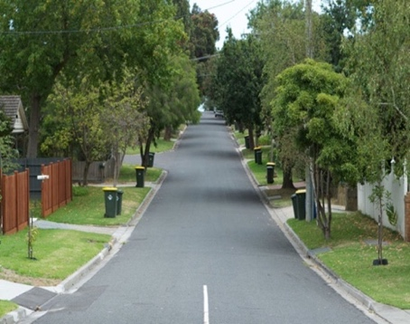 | Service |  | Provision of transport services to the community including vehicular, cycling and other relevant modes. Provision of off-street carpark facilities at key locations.
 | Service Objective |  | To provide the community and road users with a safe, functional and fit for purpose road and pathway network. To provide safe and suitable off-street carparking facilities.
Key Challenges and Choices
Sustainable Transport |  | City Redevelopment |  |  | Population Change and Changing Use
- The need to steadily accommodate electric vehicles and driverless vehicles on the existing road network and carparks.  - Use and reuse of sustainable materials for road construction. |  | - Management of development impacts on the road network such as construction vehicle damage and utility renewals and connections affecting road pavement.  - Management of on street parking issues. |  |  | - Population growth and increasing dwelling density leading to increase demand on local roads and connections with higher order roads.  - Further redevelopment of CBD and precinct areas places higher demand for off street car parking.
Current Condition
The current condition of the road asset portfolio is considered very good to good condition with a small number of roads and off street car parks in poor and very poor condition. These assets have been priortised for renewal in the road and carpark renewal programs.
Asset Performance Assessment
Current Performance |  |  |  | Fit for the Future?
The current network of local roads and kerbs are performing very well and have been progressively renewed over the past 10-20 years to maintain and improve the overall network condition. Significant investment continues to be allocated to maintaining a high level of service for the road network and this is reflective in the current asset condition profile.  Provision of car parking continues to be challenging as demand increases in and around activity areas, business districts, shopping and foreshore areas. |  |  |  | The local road network and kerb assets are considered fit for the future. Continued integrated planning with higher use roads managed by State authorities is essential to ensure transport service levels are maintained throughout Frankston City Council area. Continued investment in road and car park renewal is required to maintain the current level of service.  Optimsation of key off street car parks within the Franskton Central Activity Area is required to manage increasing demand. This will conicide with the expansion of additional transport modes such as pedestrian and cycle paths to key business areas, to manage the demand for off street car parking space and possibly the local road network as well.

Relevant Asset Activities
Non-discretionary – Operations and Maintenance | Non-discretionary – Renewal | Discretionary - Growth
- Maintenance and repairs to roads such as patching potholes, crack sealing  - Line marking and marking of car park bays  - Street sweeping, cleaning and leaf removal  - Inspections of the road network | - Resurfacing of existing roads  - Road reconstruction or major patching of road surface  - Replacement of sections of kerb and channel in poor condition  - Replacement of car park surface or significant areas of car parks | - Road safety and traffic management improvements  - Widening or duplication of existing roads  - Traffic calming treatments  - Construction of new or expanded car parking areas
Financial Projections
The great majority of funding over the next 10 years is allocated to non-discretionary road and carpark operations, maintenance and renewal. Programs to enhance existing car parking and various traffic management improvements are proposed to improve accessibility, traffic flow and safety throughout the local road network. A steady funding increase is required for road and carpark asset operations, maintenance and renewal over the forward 10 years to maintain assets to the current level of service.

Costs
 | 2023  ($’000) | 2024  ($’000) | 2025  ($’000) | 2026  ($’000) | 2027  ($’000) | 2028  ($’000) | 2029  ($’000) | 2030  ($’000) | 2031  ($’000) | 2032  ($’000)
Operations/ Maintenance | 3039 | 3100 | 3162 | 3225 | 3290 | 3355 | 3422 | 3491 | 3561 | 3632 | 33277
Renewal | 4940 | 5476 | 5301 | 4824 | 5159 | 5868 | 6076 | 5811 | 6560 | 6560 | 56575
Growth | 3456 | 1221 | 831 | 1063 | 2476 | 3172 | 1035 | 665 | 470 | 471 | 14860
Total | 11435 | 9797 | 9294 | 9112 | 10925 | 12395 | 10533 | 9967 | 10591 | 10663 | 104712

Bridges and Pedestrian Structures
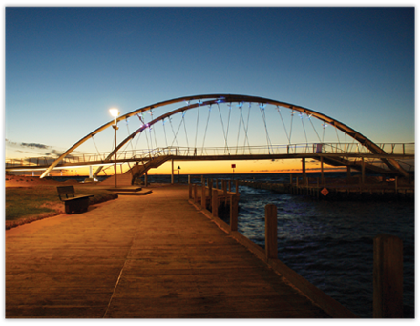 | Service |  |  | Provision of connecting transport services to the community including vehicular, cycling, pedestrian and other relevant modes.
 | Service Objective |  |  | To ensure that our bridges, major culverts and pedestrian structures are safe and functional.
Key Challenges and Choices
Ageing Assets |  | Changing use |  |  | Climate Change
- Bridges, major culverts and pedestrian structures in a coastal environment are subject to increased corrosion and will require ongoing monitoring and maintenance to keep them in a safe and serviceable condition. |  | - Unauthorised loading of road bridges and major culverts can result in increased deterioration and risk.  - Monitoring the road network and use of bridge structures to manage the assets in safe and reliable manner.  - Increased loading and use of older structures may require upgrade to newer standards. |  |  | - Sea level rise and coastal inundation can cause increase in corrosion for bridges structures resulting in the need to treat, maintain and renewal these elements early.
Current Condition
The current condition of the bridges and pedestrian structures are considered as very good to fair. There are no bridges or pedestrian bridges in poor or very poor condition overall. An ongoing bridge inspeciton and renewal program will address any bridge elements that are identified in poor condition over the next 10 years.
Asset Performance Assessment
Current Performance |  |  | Fit for the Future?
The bridge and pedestrian structure portfolio is performing very well. Ongoing monitoring and condition assessment is being undertaken to ensure that any bridge or structure elements identified in poor condition are treated, maintained or renewed under the ongoing renewal programs |  |  | The bridge and pedestrian structure portfolio is performing well and is considered fit for the future. However bridge and pedestrian structures in a coastal environment can degrade rapidly and climate change effects such as sea level rise and salt water inundation can accelerate deterioration. Ongoing monitoring and use of detailed structure assessment techniques will be required to ascertain extent of deterioration. The current renewal program may have to adapt and be flexible to accommodate increased renewal and maintenance funding needs to address any poor condition bridge assets identified as a result of more indepth or ongoing assessment activities.

Relevant Asset Activities
Non-discretionary – Operations and Maintenance | Non-discretionary – Renewal | Discretionary - Growth
- Bridge surface and handrail repairs  - Weed and vegetation control  - Programmed inspections | - Replacement of bridge decks, handrails, guardrail, supporting elements such as piers and abutments | - Replacement of bridges to a higher standard  - Upgrade of pedestrian bridges to accommodate cyclist and shared path requirements
Financial Projections
All bridge and pedestrian structure funding is allocated to non-discretionary operations, maintenance, and renewal over the next 10 years. A steady funding increase is required for bridge non-discretionary activities over the next 10 years to maintain these assets to the current level of service as they age over time.

Costs
 | 2023  ($’000) | 2024  ($’000) | 2025  ($’000) | 2026  ($’000) | 2027  ($’000) | 2028  ($’000) | 2029  ($’000) | 2030  ($’000) | 2031  ($’000) | 2032  ($’000)
Operations/ Maintenance | 412 | 420 | 428 | 437 | 446 | 454 | 464 | 473 | 482 | 492 | 4507
Renewal | 208 | 442 | 454 | 465 | 477 | 489 | 502 | 515 | 528 | 528 | 4608
Growth | 0 | 0 | 0 | 0 | 0 | 0 | 0 | 0 | 0 | 0 | 0
Total | 620 | 862 | 882 | 902 | 923 | 943 | 966 | 988 | 1010 | 1020 | 9115

Pathways
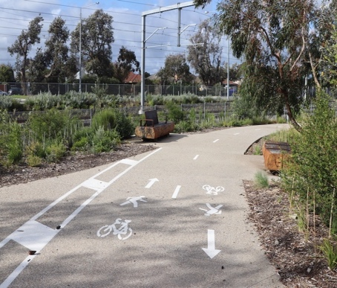 | Service |  |  | Connecting to the community to the pedestrian transport network including cycling, pedestrian, and other relevant modes.
 | Service Objective |  |  | To provide a connected network of paths that allows for the safe movement of pedestrians and other users around the city.
Key Challenges and Choices
Changing Demand |  | City Redevelopment |  |  | Sustainable Modes of Transport
- Population growth and increasing dwelling density has led to a rise in demand for use of pathways.  - Ageing population and associated increase in impaired mobility needs.  - Active transport has seen significant increase in demand as electric devices enable more users to utilise the pathway network. |  | - Development works can damage paths during construction.  - Developing areas can introduce additional pathways which may require connection and linkage to the broader pathway network. |  |  | - Community demand for access to pathways and increased pathway network as transport modes advance and become more accessible to a wider range of users (i.e. ebikes)
Current Condition
The current condition of pathways is considered in good to fair overall with a small number of pathways in poor condition. These pathways have been priortised for full or partial renewal in either the ongoing Footpath Renewal Program or the Shared Path Renewal Program within the capital works program.
Asset Performance Assessment
Current Performance |  |  | Fit for the Future?
The current network of pathways and footpaths are performing well. Historic and ongoing investment in renewal of both footpaths and shared paths continues to maintain the pathway network to a high level of service for the Franskton community. This is reflective in the current asset condition profile. |  |  | Ongoing inspections and monitoring of footpaths and shared paths throughout the City will enable assets identified in poor condition to be maintained or replaced under the current ongoing renewal programs.  Current pathway programs such as the Pathway Development Plan Implementation Program and Minor Pathway Program will address areas of demand to either connect new development pathways to the existing network or upgrade exising secitons.  Furthermore, specific pathway upgrade projects such as the link from Penlink Rd to Baxter Trail address gaps in the network. These discretionary projects will continue to be required to meet demand for an expanded and connected pathway network to service the City.

Relevant Asset Activities
Non-discretionary – Operations and Maintenance | Non-discretionary – Renewal | Discretionary - Growth
- Pathway repairs such as pothole patching, grinding, relaying of pavers  - Pathway inspections  - Weed and vegetation control  - Sweeping and pathway cleaning | - Replacement of sections of existing pathways to an equivalent standard | - Accessibility improvements such as installation of tactile strips at intersections and compliant kerb ramps at intersections  - Widening or improving the surface of existing pathways  - Extension of the pathway network to address gaps in connectivity.
Financial Projections
A balance of funding is allocated between non-discretionary operations and maintenance and renewal and new and upgraded segments of pathway. A steady funding increase is also required for pathway renewal over the forward 10 years to maintain the network to the current level of service.

Costs
 | 2023  ($’000) | 2024  ($’000) | 2025  ($’000) | 2026  ($’000) | 2027  ($’000) | 2028  ($’000) | 2029  ($’000) | 2030  ($’000) | 2031  ($’000) | 2032  ($’000)
Operations/ Maintenance | 716 | 730 | 745 | 760 | 775 | 790 | 806 | 822 | 839 | 856 | 7839
Renewal | 1367 | 1458 | 1661 | 1571 | 1577 | 2047 | 1910 | 2138 | 1648 | 1648 | 17025
Growth | 2254 | 2274 | 1446 | 1389 | 2050 | 839 | 876 | 946 | 142 | 142 | 12358
Total | 4337 | 4462 | 3852 | 3720 | 4402 | 3676 | 3592 | 3906 | 2629 | 2646 | 37222

Stormwater Drainage
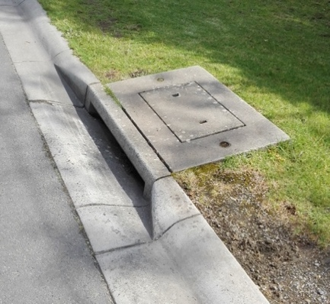 |  | Service | Provision of flood mitigation and drainage to the community including stormwater treatment and pollutant removal from stormwater run-off
 |  | Service Objective | To protect the community from flooding and improve the quality of stormwater runoff discharged to natural water courses
Key Challenges and Choices
Ageing Assets | City Redevelopment |  |  |  | Climate Change
- Some older stormwater assets do not meet stormwater run-off capacity levels of service and may require upgrade to improve flood immunity.  - More recurrent flooding incidents.  - The ability to fund timely renewal and upgrade of stormwater assets in poor condition, consequently increasing the maintenance cost. | - Further high and medium density developments may require change to existing drainage system function and capacity.  - Subdivision growth will lead to more stormwater run-off creating pressure on the existing stormwater network and the need for local stormwater treatment assets.  - Further growth and development areas may be conditioned with additional stormwater treatment devices which will increase ongoing maintenance and renewal costs to maintain these new assets. |  |  |  | - Coastal inundation and sea level rise is beginning to affect the stormwater network as higher tides reach up stormwater pipes near the bay. This may result in increased corrosion and deterioration of affected pipes and possibly cause localised flood issues requiring network upgrade.  - More frequent and intense storm events will pose an increased risk of flooding and reduce the reliability of capacity of the stormwater system  - Increased pressure and demand to treat stormwater prior to it entering the bay. This may result in further water harvesting and water sensitive urban design assets being needed.
Current Condition
The current condition of the stormwater drainage network is considered in good to poor condition, with a small number of stormwater assets in very poor condition based on current information available. The Stormwater Renewal and Upgrade Program along with a number of local catchment renewal and upgrade projects are addressing the immediate and future stormwater management needs in low lying or historically problematic areas within the City.

Asset Performance Assessment
Current Performance |  |  |  | Fit for the Future?
The current stormwater network is steadily ageing and will require significant and increasing investment over the next 10 years to renew and upgrade assets idenified in poor condition and upgrade existing local catchment areas to improve levels of service. The significantly expanded stormwater program covers both renewal and upgrade of the network and addresses historically problematic areas such as Dandenong Road East and areas identified under the Frankston South Drainage Strategy. These programs need to continue to ensure the stormwater network is brought up to a suitable level of service for these areas. |  |  |  | Continued and expanding assessment of the stormwater assets will provide more detail on the current condition of the network and future needs.  The stormwater network and water treatment assets will require continued and increased funding to address both increased renewal and upgrade demand of either harvesting or treatment of stormwater before it enters the bay. It is critical that the City continues to focus and expand its current programs in this area to manage likely impacts and improve levels of service.

Relevant Asset Activities
Non-Discretionary – Operations and Maintenance | Non-Discretionary – Renewal | Discretionary – Growth
- Stormwater Pit cleaning  - Stormwater Pipe cleansing and removal of debris, sediment, etc  - Removal of litter from stormwater pollutant traps  - Programmed inspections | - Replacement of pits and pipes  - Relining of stormwater pipes  - Renewal of stormwater treatment and harvesting devices | - Replacement of pipes to a higher hydraulic capacity  - Extension of the stormwater drainage network  - Installation of stormwater quality improvement devices (e.g., raingardens, litter traps, etc)  - Stormwater harvesting initiatives
Financial Projections
The great majority of funding is allocated to non-discretionary operations and maintenance and renewal. Several drainage upgrade programs addressing the Dandenong Road East and Frankston South areas are included in the non-discretionary renewal funding forecast. A funding increase for stormwater drainage asset operations, maintenance and renewal is required over the forward 10 years although the forecast varies. Frankston and Beauty Parks Stormwater Treatment and Harvesting Program, Dam Safety Improvement and other drainage improvement programs contribute to the increase in discretionary new funding required over the next 10 years. Further asset condition assessments and information will likely change these funding requirements in future.

Costs
 | 2023  ($’000) | 2024  ($’000) | 2025  ($’000) | 2026  ($’000) | 2027  ($’000) | 2028  ($’000) | 2029  ($’000) | 2030  ($’000) | 2031  ($’000) | 2032  ($’000)
Operations/ Maintenance | 2439 | 2488 | 2537 | 2588 | 2640 | 2693 | 2747 | 2802 | 2858 | 2915 | 26705
Renewal | 1937 | 2068 | 2679 | 3829 | 1983 | 1520 | 3596 | 4159 | 3595 | 3595 | 28961
Growth | 2558 | 1505 | 1919 | 3637 | 1334 | 572 | 2514 | 3088 | 3675 | 3675 | 24477
Total | 6934 | 6061 | 7135 | 10054 | 5957 | 4785 | 8857 | 10049 | 10128 | 10185 | 80143

Open Space Assets
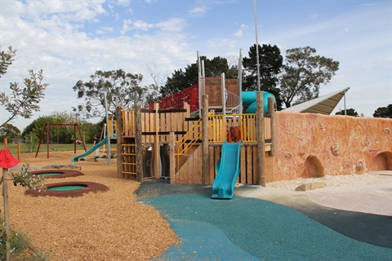 | Service |  | Provision of open space assets to support active and passive recreation activities  Provision of streetscapes amenity and preservation/ management of flora and fauna, bushland, wetland and foreshore areas
 | Service Objective |  | To enhance the city’s public open space areas to enhance quality of life and promote social connectedness
Key Challenges and Choices
Open Space Demand |  | Changing Demographics and Use |  |  | Climate Change and Sustainability
- Higher density living and increased use of open space areas will require both additional provision of open space and enhanced functionality of existing open space areas. This may result in the creation of more assets which will require more asset maintenance and renewal funding in order to maintain higher level of service areas. |  | - Population increases will increase demand for specific outdoor recreation activities, features and landscape.  - Sporting trends may change demand over time requiring the reconfiguration of open space and sporting assets. Traditional recreational opportunities such as football grounds could move towards bike pump tracks, skate parks and exercise stations. |  |  | - Climate change may require assessment of viability of providing ongoing services such as irrigation to sports fields.  - Demand for more sustainable sources of energy and water.  - Climate change impacts on natural areas such as foreshore erosion.
Current Condition
The current condition of the open space asset portfolio is considered in very good to fair condition, with a small number of assets in poor and very poor condition. These open space asset have been priortised for full or part renewal in the capital works program.

Asset Performance Assessment
Current Performance |  |  |  | Fit for the Future?
The current open space asset portfolio is performing well. Significant investment in park upgrades in key locations has ensured a high level of service for Franskton City.  This is reflective of the current asset condition profile and also the quality and extent of parks and open space provided by Council. This includes streetscape and foreshore area upgrades as well as playspace and sporting ground upgrades. These assets will require ongoing maintenance and renewal in order to maintain them to the current level of service. |  |  |  | The well supported park, open space, streetscape and foreshore upgrade programs and projects are needed to support increasing demand of the community for passive and active spaces. The assets which result from the projects will require an increase to the large ongoing asset maintenance and renewal program to ensure they are maintained appropriately.  Further redevelopment and enhancement of key regional parks may be required to meet community demand and increasing use.

Key Focus Areas over the next 10 years
Non-Discretionary – Operations and Maintenance | Non-Discretionary – Renewal | Discretionary - Growth
- Hazard/defect inspections  - Mowing, vegetation/weed control  - Garden bed maintenance  - Litter collection and facility cleaning  - Graffiti removal | - Replacement of playground equipment  - Replacement of park furniture  - Rejuvenation or replacement of entire playing courts or sports fields to an equivalent standard | - Playing court extension  - Replacement of playground equipment to a higher standard  - Development of new park or reserve
Financial Projections
The great majority of funding is allocated to non-discretionary operations and maintenance and renewal. The large ongoing operations and maintenance budget requires steady increase to account for new assets and increasing maintenance costs. Several improvement programs such as urban revitalisation, play space upgrades and park upgrades are funded in the first 7 years of the 10-year forecast to meet current and future demand for enhanced open space areas within the City.

Costs
 | 2023  ($’000) | 2024  ($’000) | 2025  ($’000) | 2026  ($’000) | 2027  ($’000) | 2028  ($’000) | 2029  ($’000) | 2030  ($’000) | 2031  ($’000) | 2032  ($’000)
Operations/ Maintenance | 15448 | 15757 | 16072 | 16393 | 16721 | 17056 | 17397 | 17745 | 18100 | 18462 | 169150
Renewal | 6093 | 6912 | 8926 | 9517 | 8711 | 10025 | 4763 | 6061 | 7829 | 7829 | 76666
Growth | 12391 | 10568 | 14681 | 15145 | 14176 | 25874 | 5106 | 6873 | 7294 | 7294 | 119402
Total | 33932 | 33237 | 39679 | 41055 | 39608 | 52955 | 27266 | 30679 | 33223 | 33585 | 365218

Funding the Asset Plan

The integration of the Asset Plan and the Long-Term Financial Plan is critical to ensure the resources required to manage assets to agreed levels of service are provided for in Council’s financial planning instruments.

If the required resources are not provided adequately for non-discretionary asset expenditure for asset maintenance and or renewal, then a resource gap can arise. This can result in a lowering of levels of service provided to the community or risks such as public health and safety can be compromised.

Other the other hand, if the required resources are not provided adequately for discretionary asset expenditure for the timely upgrade and expansion of existing assets or the construction of new assets, it can result in a difference between the current level of service provided by assets and the level of service demand required of the assets.

This balance is and will continue to be an ongoing challenge for Council within a constrained financial environment.

Funding Community Needs

Balancing the funding needs of existing assets and meeting the current and future needs of the community through investment in new and upgraded assets is an ongoing consideration for Council.

Ongoing asset needs covered in this Asset Plan are identified through our regular asset inspections, risks management processes or to meet current asset statutory obligations. These needs are funded first and given priority above discretionary funding to ensure public health and safety and continuation of current services.

The community identified principles identified will be used to inform the prioritisation of discretionary funding available. The principles have identified areas for further investment in new and upgraded assets to meet the needs of the community over the next 10 years. These principles will be progressively implemented over the life of this Asset Plan. Once constructed, these new and upgraded assets will require ongoing maintenance and renewal and will add to the ongoing funding needs over time.

The diagram below demonstrates how the community developed principles will inform Council’s allocation of funding and prioritisation over the life of the Asset Plan.

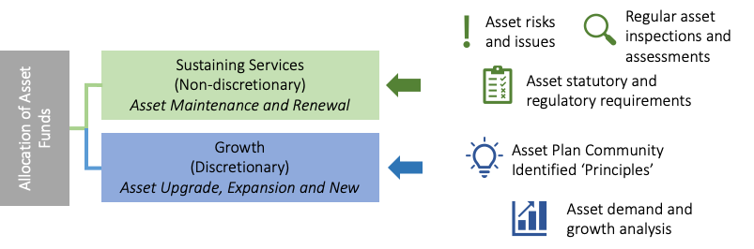
Figure 9 – Community developed principles in action

Financial Projections

This section outlines the projected expenditure requirements for our infrastructure over the next 10 years. These funding requirements have been determined based on the affordability assessments made in our Financial Plan and represent the investment that is required to maintain our existing levels of service

Whether Council’s renewal funding is sufficient depends on many variables including how long individual assets last. Through ongoing investigation and monitoring, including periodic condition surveys, Council is gaining a better understanding of how much it needs for renewal. Indications at present suggest that approximately $24 to $26M per annum is in the right order.

Council is currently addressing an outstanding backlog of asset renewals. These assets that require renewal and replacement will be addressed over the next 10 years.
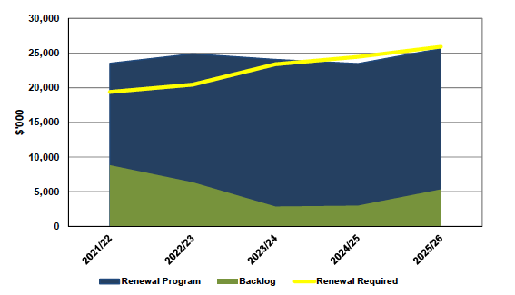
Figure 10 – Asset renewal funding forecast
A shown above, Council is fully funding its long-term asset renewal and replacement needs over the next 10 years.

Financial Plan Integration

The forecasts included in this Asset Plan for the projected asset costs are consistent with our Financial Plan and cover the planned asset activities in the next ten (10) years. All funding requirements identified for each asset class have been allocated in the Financial Plan. This will require future monitoring and further analysis as new asset information becomes available such a new asset condition data. Funding requirements may potentially change and require adjustment to both this Asset Plan and the Long-Term Financial Plan.

Total Expenditure

The following graph shows the planned expenditure across the infrastructure assets included in this Asset Plan over the next 10 years.

Figure 11 - Forecast Total Asset Expenditure
The following table summarises projected expenditure by asset class over the next 10 years.
Asset Class | Renewal  ($’000) | Growth  ($’000) | Operations and Maintenance ($’000) | Total  ($’000)
Buildings | 53,227 | 95,517 | 63,057 | 211,801
Roads and Car Parks | 56,575 | 14,860 | 33,277 | 104,712
Bridges and Pedestrian Structures | 4,608 | 0 | 4,507 | 9,115
Pathways | 17,025 | 12,358 | 7,839 | 37,222
Stormwater Drainage | 28,961 | 24,477 | 26,705 | 80,143
Open Space Assets | 76,666 | 119,402 | 169,150 | 365,218
Total | 237,062 | 266,614 | 304,535 | 808,211
Table 7 - Forecast Expenditure by Asset Class

Figure 12 - Forecast Total Asset Expenditure over 10 years by Expenditure Category
Over the next 10 years we expect to budget a total of $237 million for renewing our assets and $267 million improving existing and creating new assets.

We are also projected to allocate around $305 million over the same period to operate and maintain our assets.

Combined, it is an investment of $808 million is our asset over the next 10 years which represents on average 38 per cent of our total annual expenditure. This is investment is made so that our assets remain fit-for-purpose, are safe, and support the delivery of services to our community.

Financial and Performance Indicators

The following performance measures demonstrate we are investing in our assets in a financially sustainable manner and to ensure that levels of services to the community are maintained.

Measure |  | Target | 10 Year Average  (2023 - 2032)
 | Asset Renewal and Upgrade Expenditure as a percentage of depreciation | >100% | 109%
 | Asset Sustainability Ratio (renewal funding/depreciation) | 90% to 110% | To be confirmed^
 | Asset renewal funding ratio (Proposed renewal budget over 10 years/forecast renewal budget over ten years) | 90% to 110% | To be confirmed^
 | Infrastructure per head of population | NA | $6914.8*
Table 8 – Asset Management Financial Performance Indicators
^Subject to budget development
*Current Average for Victorian Council’s is $6468.41
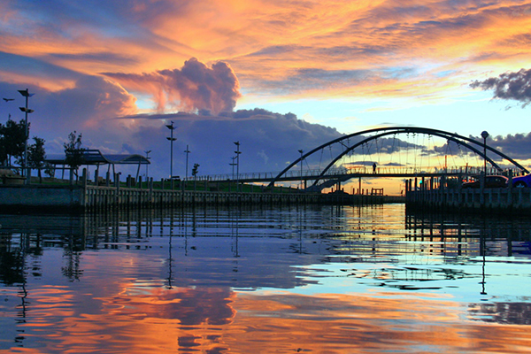

Principle has been combined with another developed under the same theme to cover similar intended outcomes
Includes forecast expenditure on “other infrastructure” assets

